**SMART SPENDING SYSTEM (SSS)**

***Team 12- Vision Quest***

Avinash Banala - 5

Sai Smaran Chinthala – 11

Rahul Nagavalli - 28

Swetcha Reddy Vangala – 41

Video URL:[**https://www.youtube.com/watch?v=Im9IugFjiBM**](https://www.youtube.com/watch?v=Im9IugFjiBM)

Github URL:[**https://github.com/SwetchaReddy/ASE-Project**](https://github.com/SwetchaReddy/ASE-Project)

**PROJECT DEPLOYMENT**

**INTRODUCTION**

* This Expense Tracker application falls in the Finance Category and serves the important purpose of managing finances which is a very important part of one’s life.
* The software product went through the design, development, and the testing phase as a part of the Software Development Lifecycle.
* The application’s interface is designed using custom art elements, the functionality is implemented using Visual Studio software, and the phase of testing the product was accomplished successfully.
* The application is not much user intensive but just comprises of having them enter the expense amount, date, category, merchant and other optional attributes.
* With this entered information, the user is able to see the expense details daily, weekly, monthly, and yearly in figures, graphs.

**FEATURES**

This system comprises of 9 features as follows:

1. **Registration:**

* The user has to register with his/her basic registration details and need to create login credentials, which will be used to sign in.

1. **Login:**

* Using the login credent.

1. **Add Income:**

* A user can add income details of the current month from various sources for his/her records.

1. **View Income:**

* The user can see a list of incomes, which were added in current month.
* Graphical representation of income will be displayed to the user for better understanding.

1. **Add Expense:**

* A user can add expense details of the current month for his/her records.

1. **View Expense:**

* The user can see a list of expenses, which were spent this month.
* Graphical representation of income will be displayed to the user for better understanding.

1. **Currency Converter:**

The user has to fill all the required fields to add special expenses and can choose only current month date.

**EXISTING SYSTEM**

* **Problem with current scenario**
* At the instant, there is no as such complete solution present easily or we should say free of cost which enables a person to keep a track of its daily expenditure easily.
* To do so a person has to keep a log in a diary or in a computer, also all the calculations needs to be done by the user which may sometimes results in errors leading to losses.
* Due to lack of a complete tracking system, there is a constant overload to rely on the daily entry of the expenditure and total estimation till the end of the month.
* **Drawbacks of the existing system**
* Maintenance of the system is very difficult.
* There is a possibility for getting inaccurate results.
* User friendliness is very less.
* It consumes more time for processing the activities.

**PROPOSED SYSTEM**

* In an effort to fix the above addressed problems, we designed a system that would make the task of keeping the expenses in check, efficient and delight task.
* This advanced system helps the user to maintain a record of his incomes and expenses.
* User first need to register using basic registration details and need to create a valid login id and password.
* After successful login, system allows the user to see the income and expense graph in the form of line chart for the selected month.
* The system makes the users work easier by calculating the current months saving, income and expenses.
* User need to add income details acquired from various sources, which can be then used for expense and saving purpose.
* User can anytime view the added income and expense details.
* A graphical representation of income and expense is shown for better understandings.
* Currency conversion plays an important role when it a user migrates from country to country.
* System allows user to select the desired country to convert all its incomes and expenses according to the selected country currency.

**PROJECT DEMO**

**APPLICATION HOME PAGE** 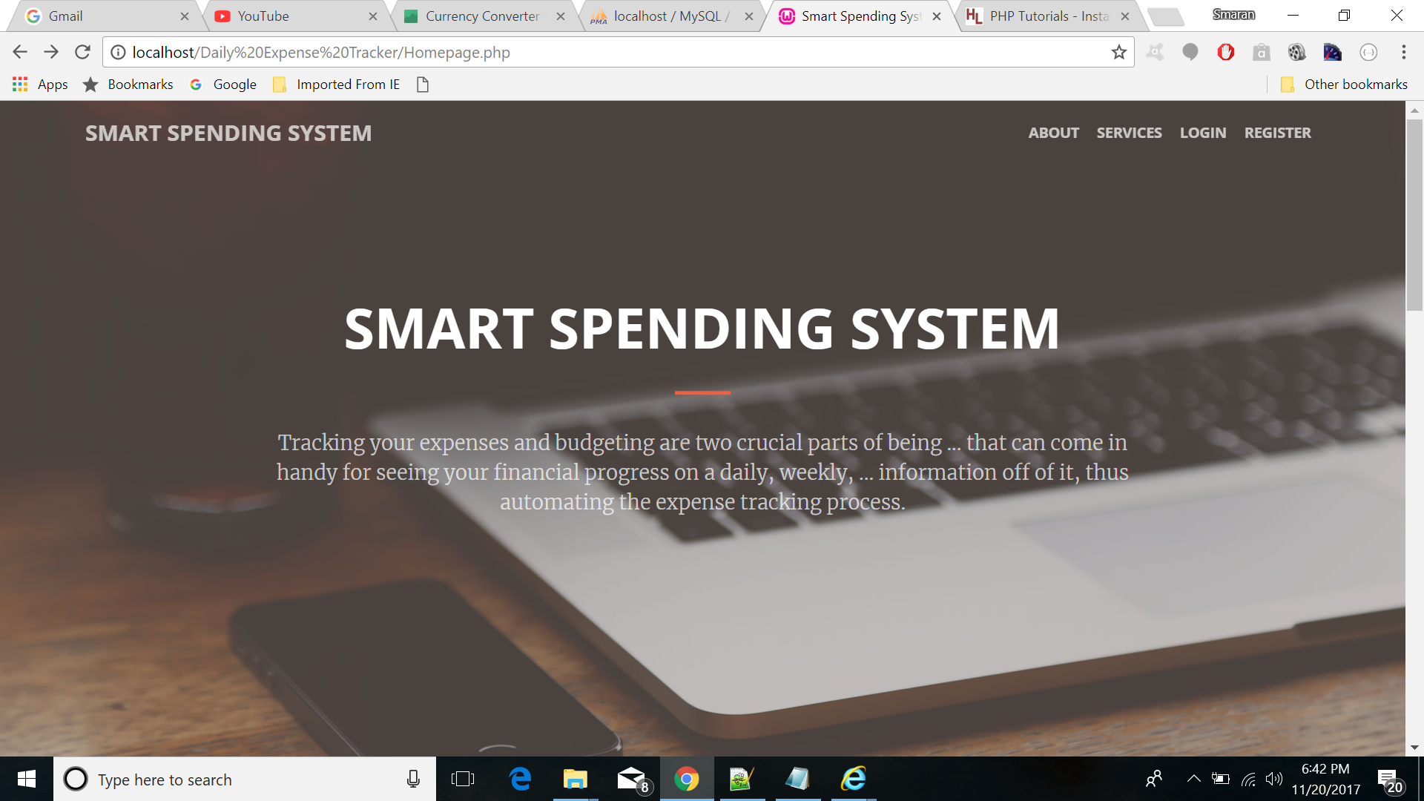

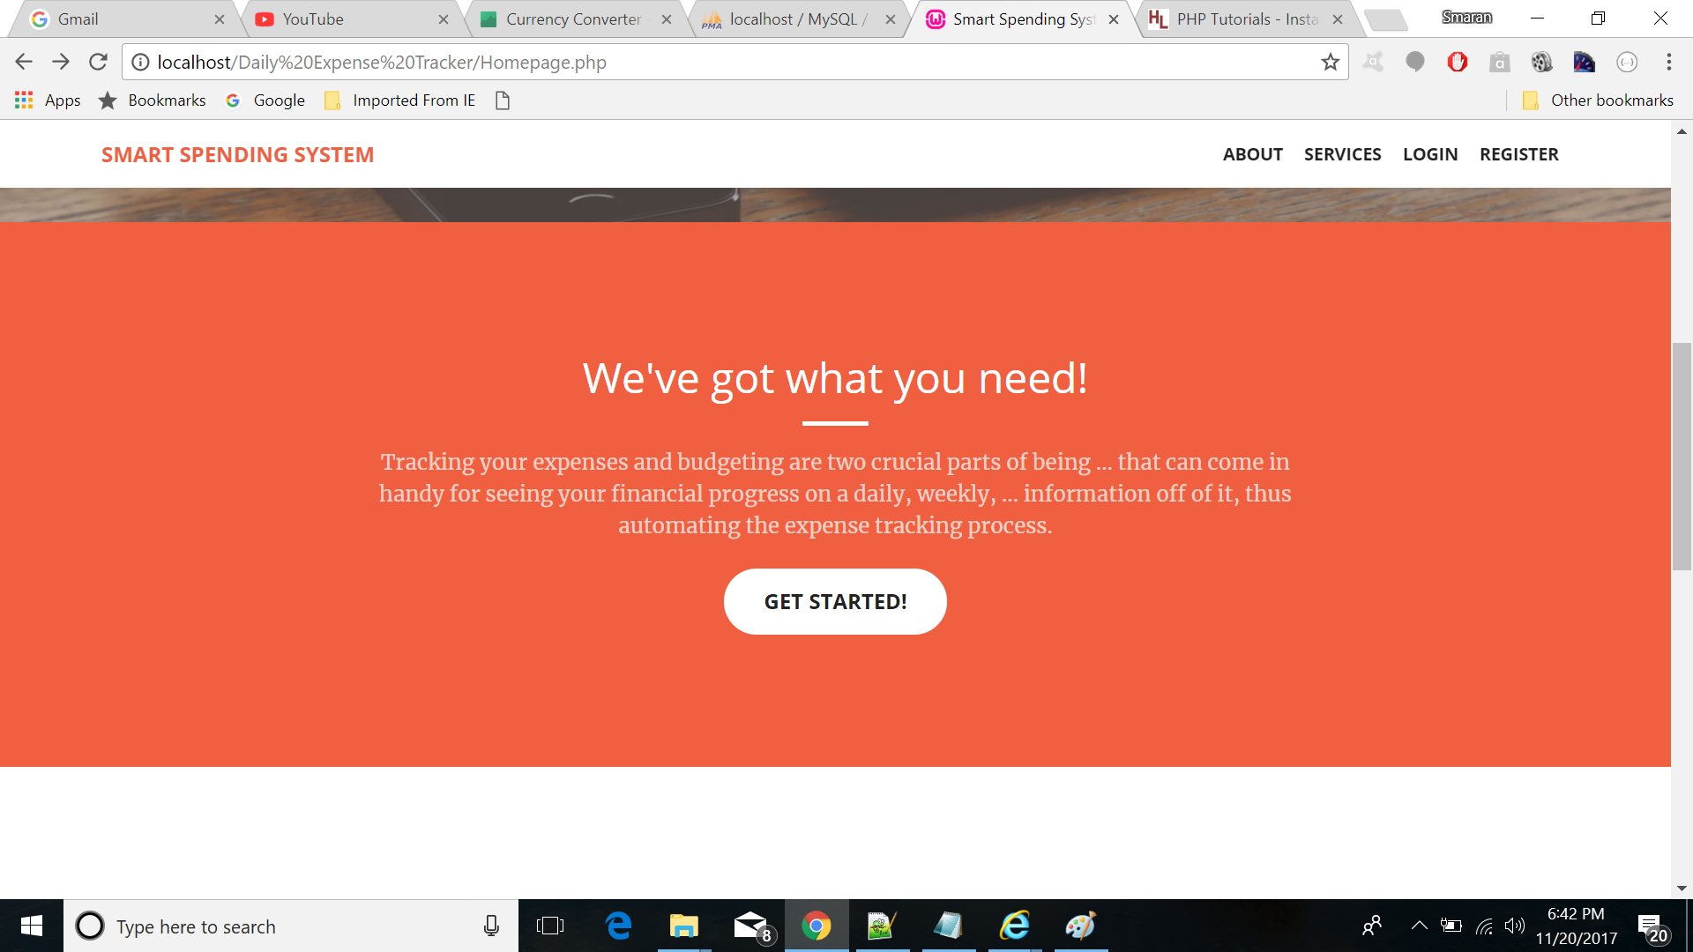

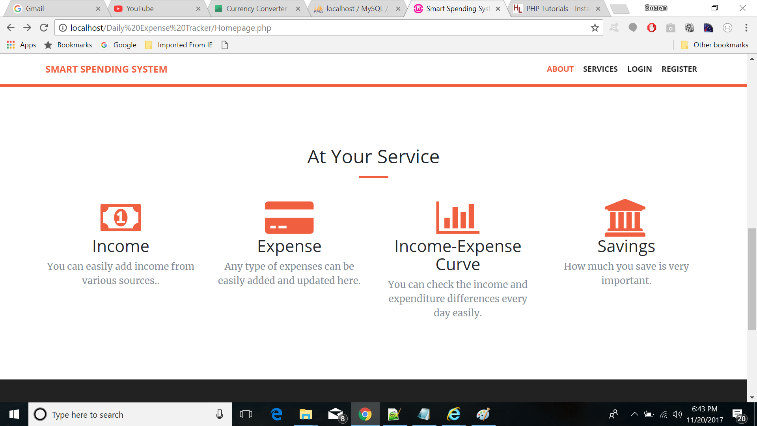

**LOGIN PAGE**

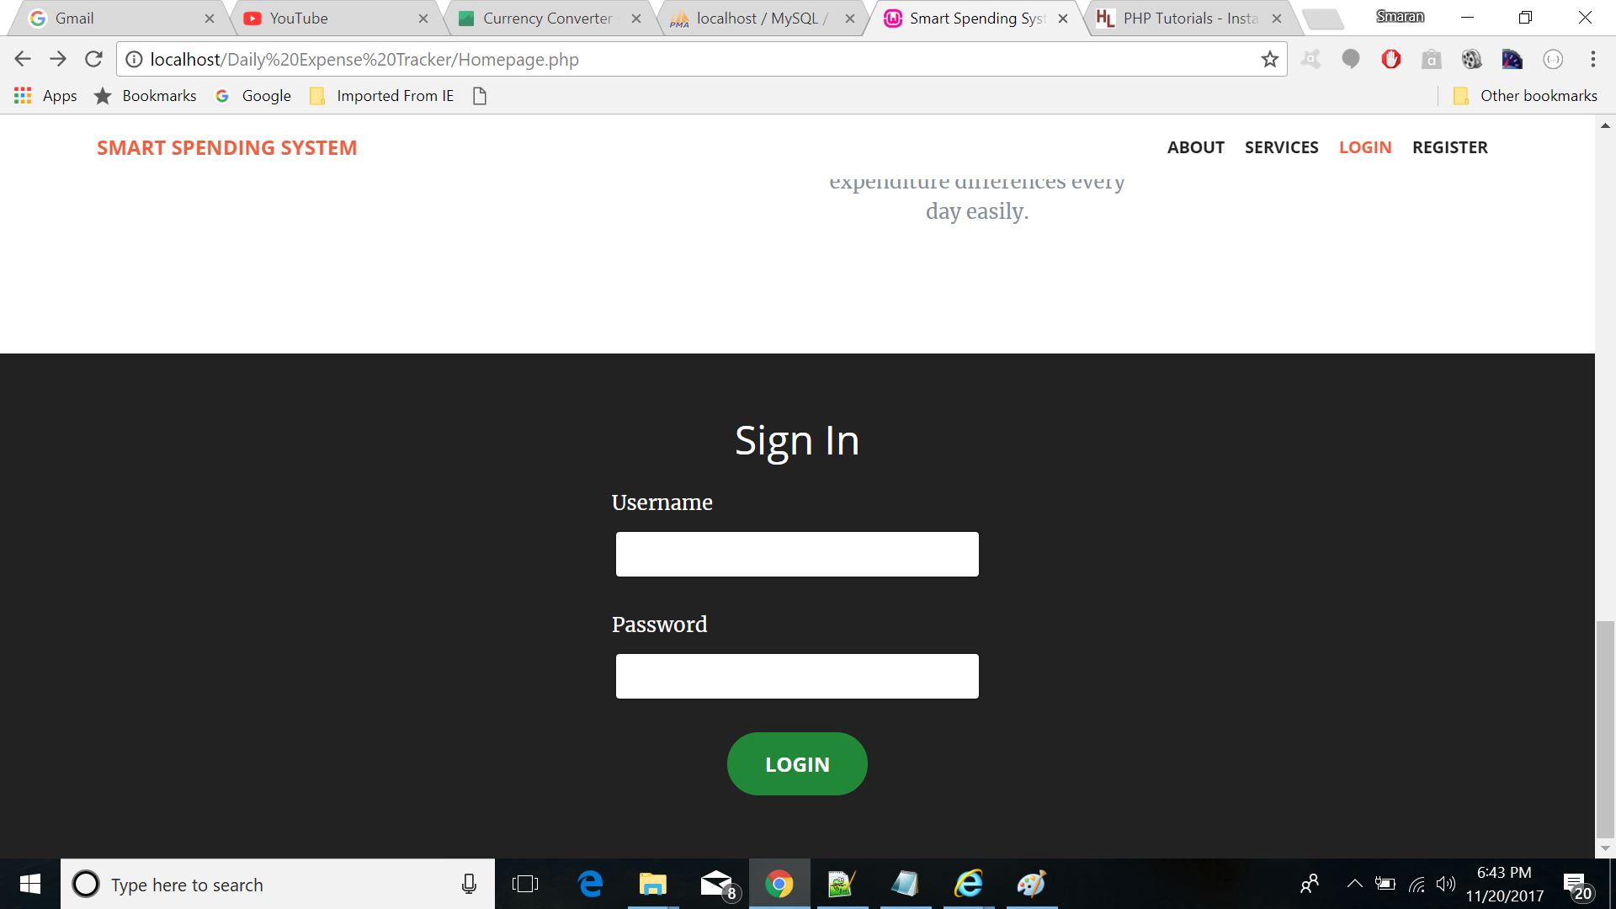

**REGISTER PAGE**

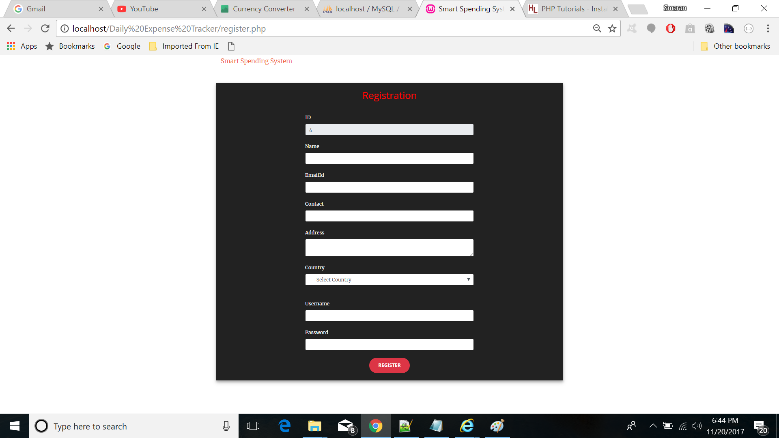

**ADD INCOME**

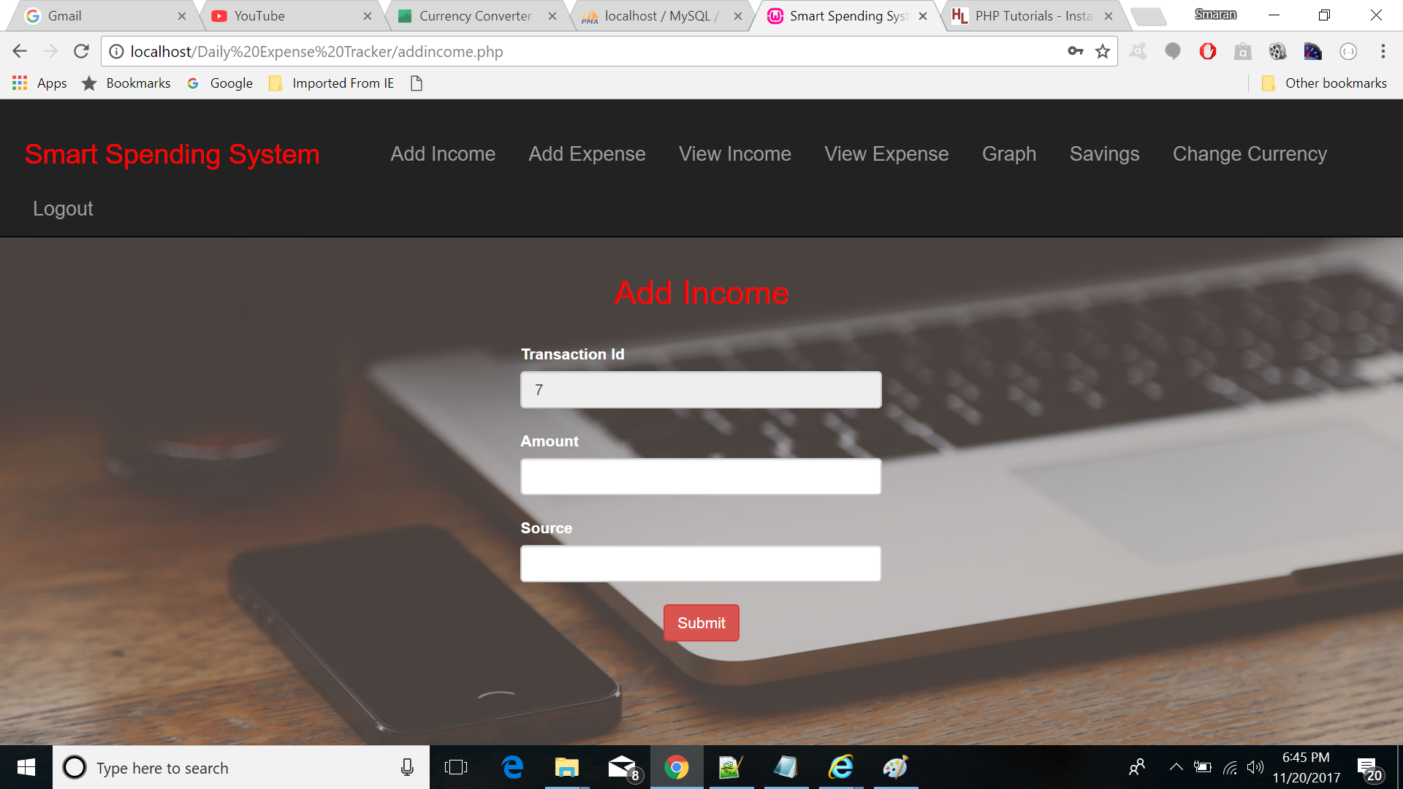

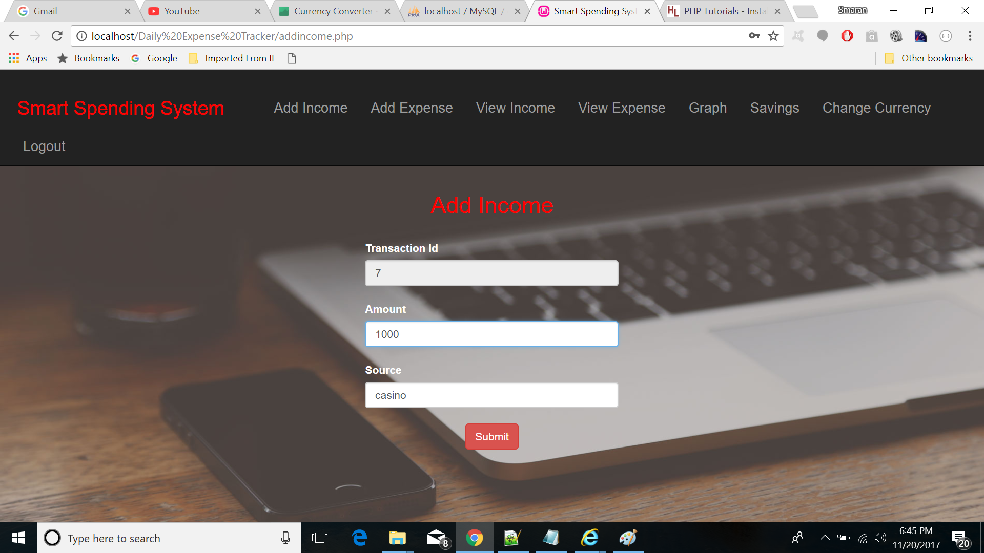

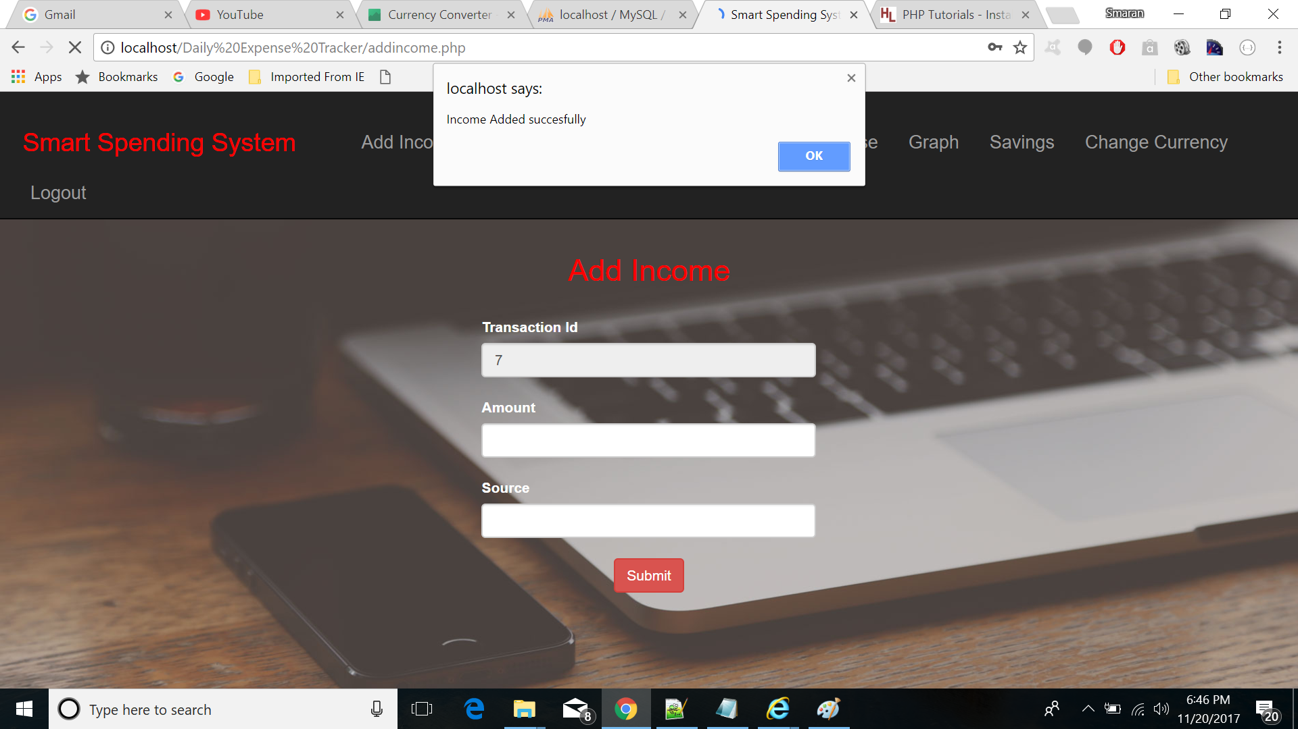

**ADD EXPENSE**

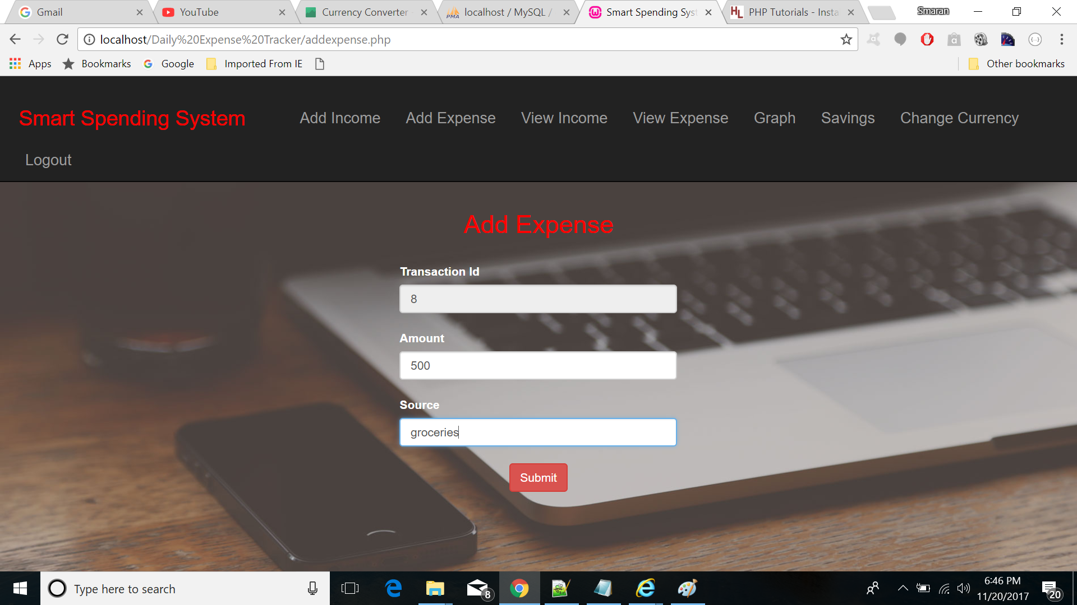

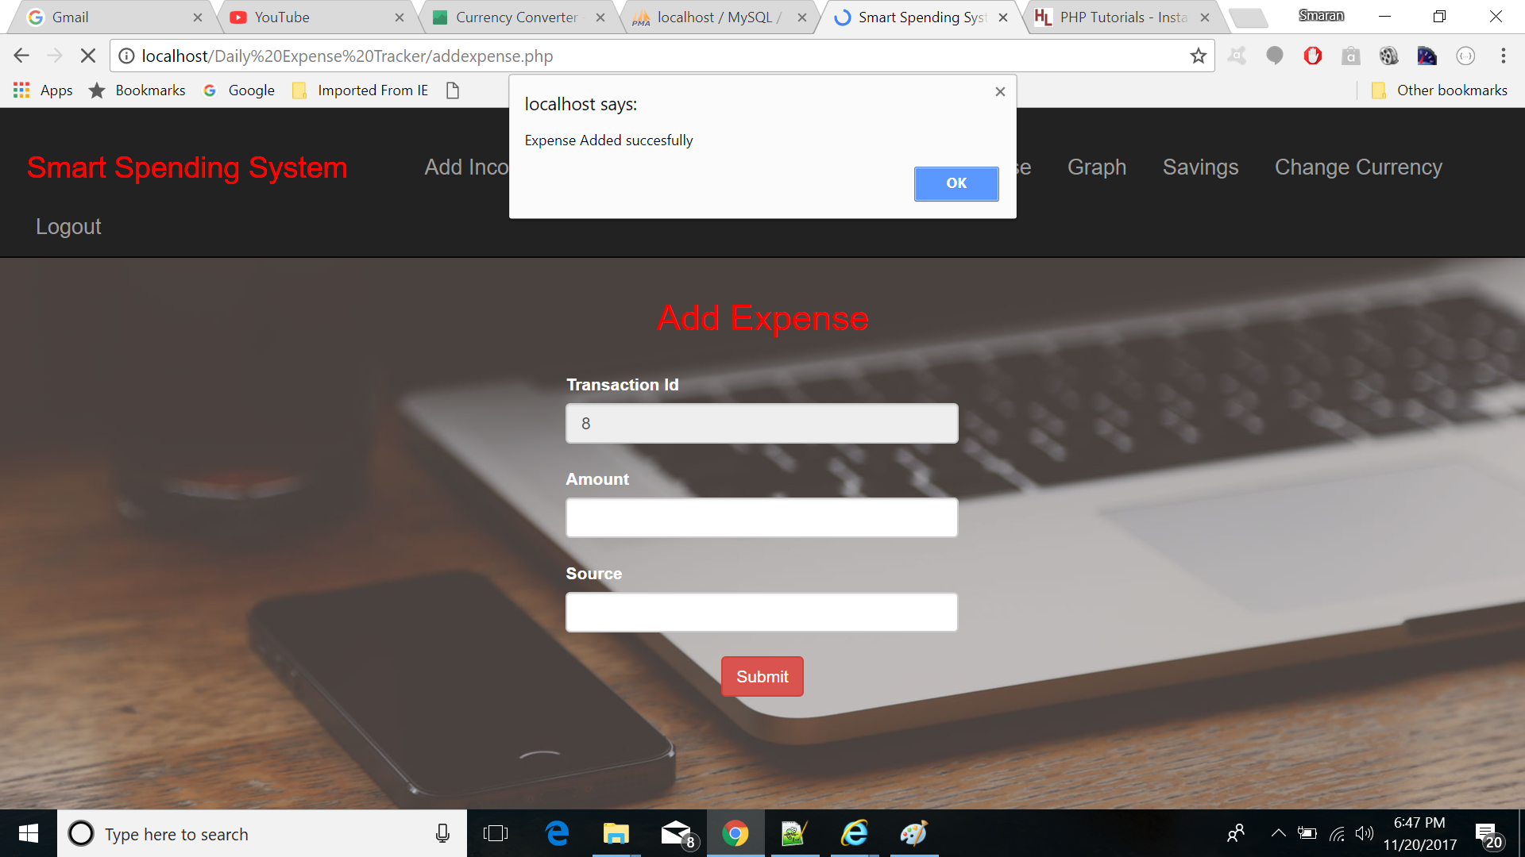

**VIEW INCOME**

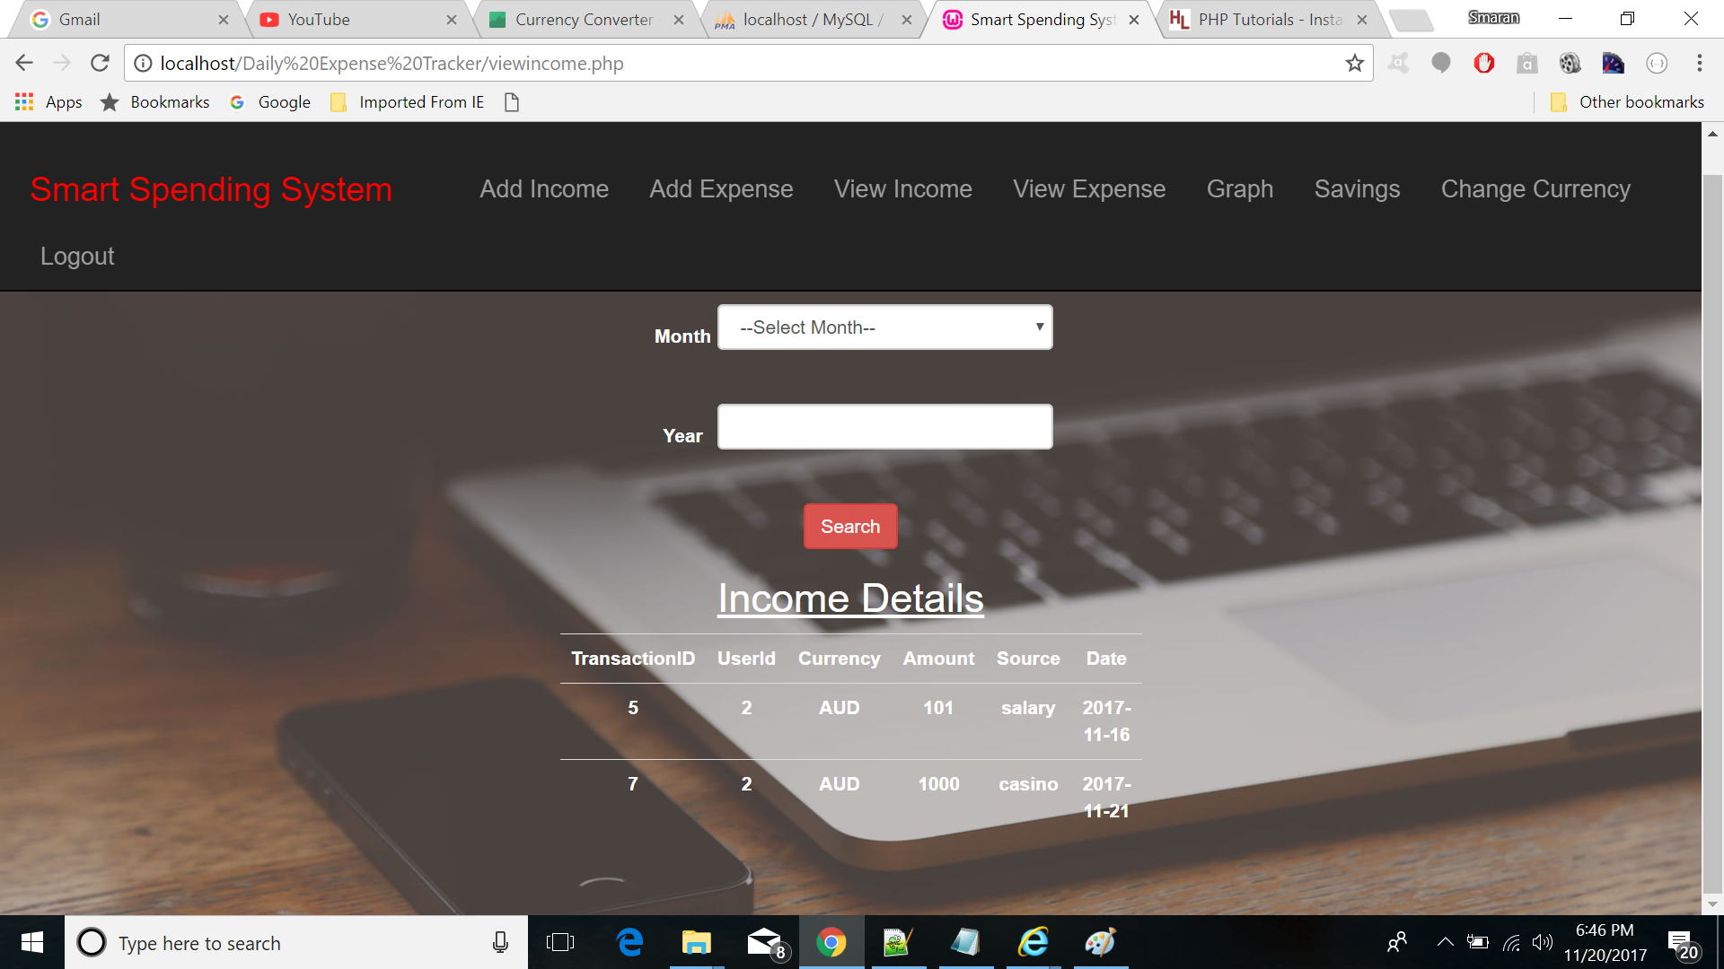

**VIEW EXPENSE**

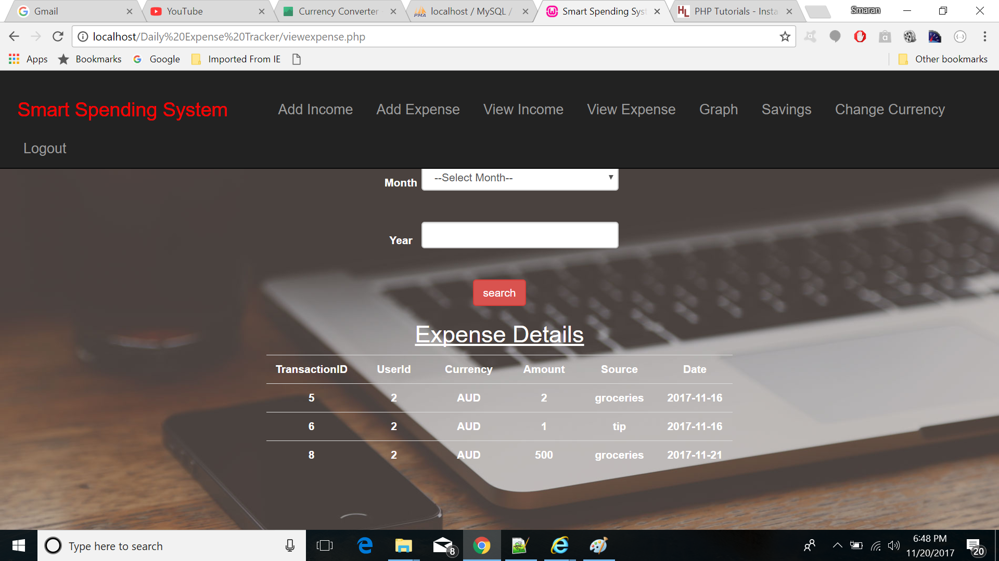

**VIEW SAVINGS**

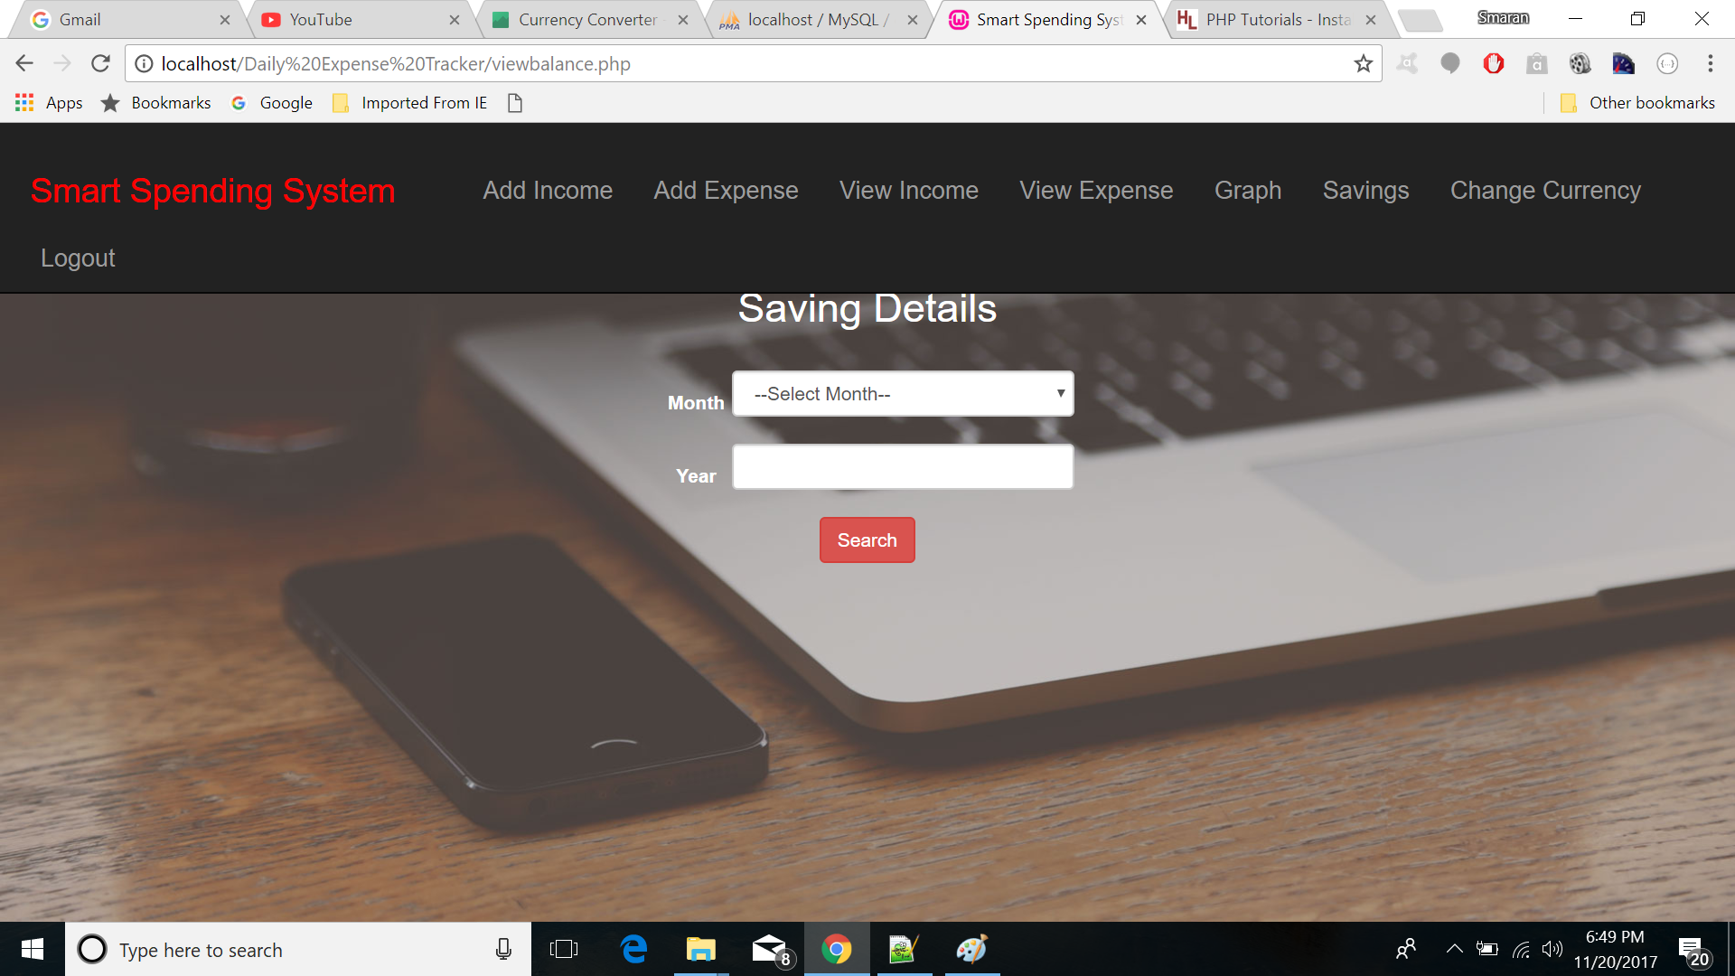

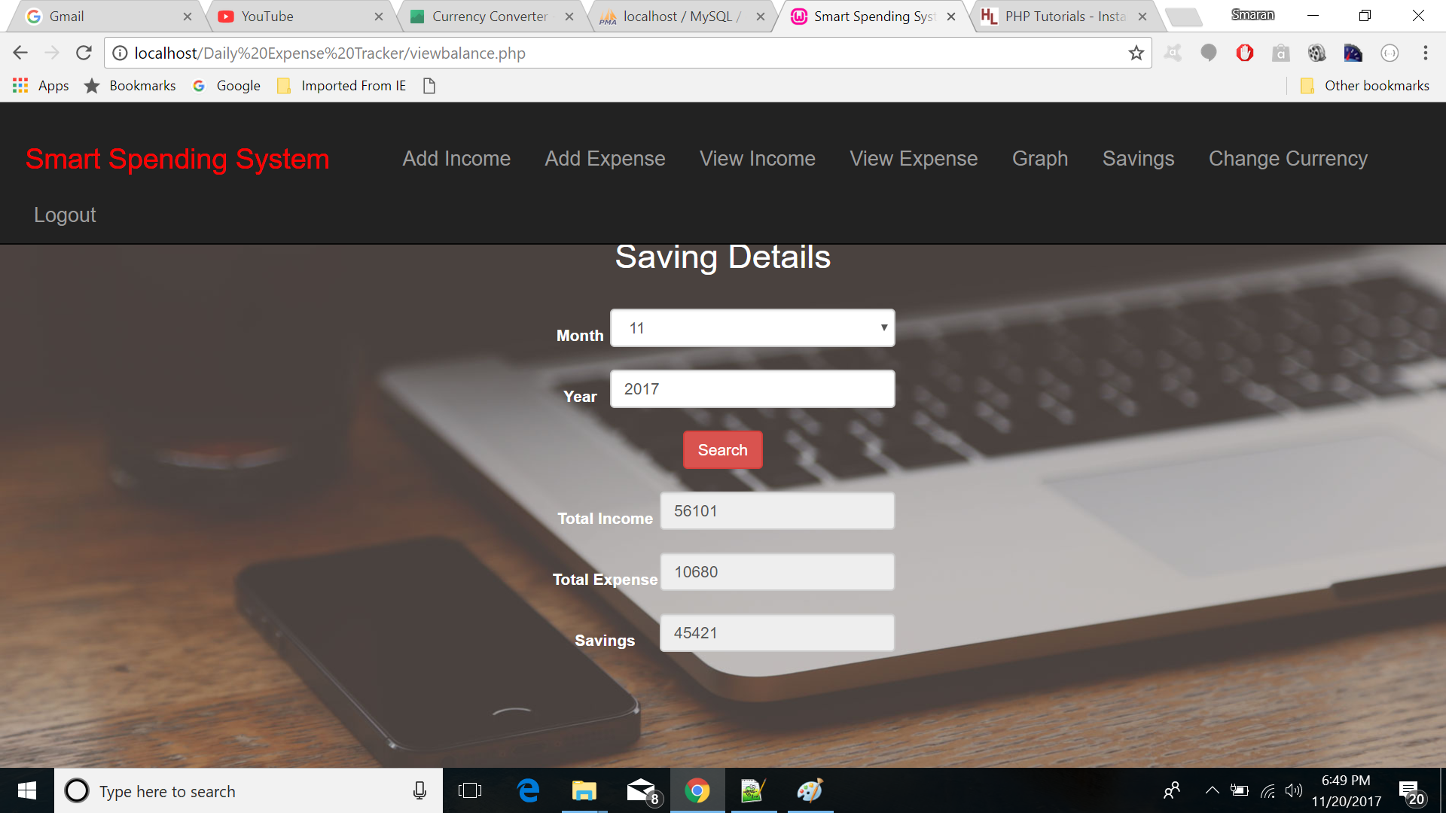

**INCOME-EXPENSE CURVE**

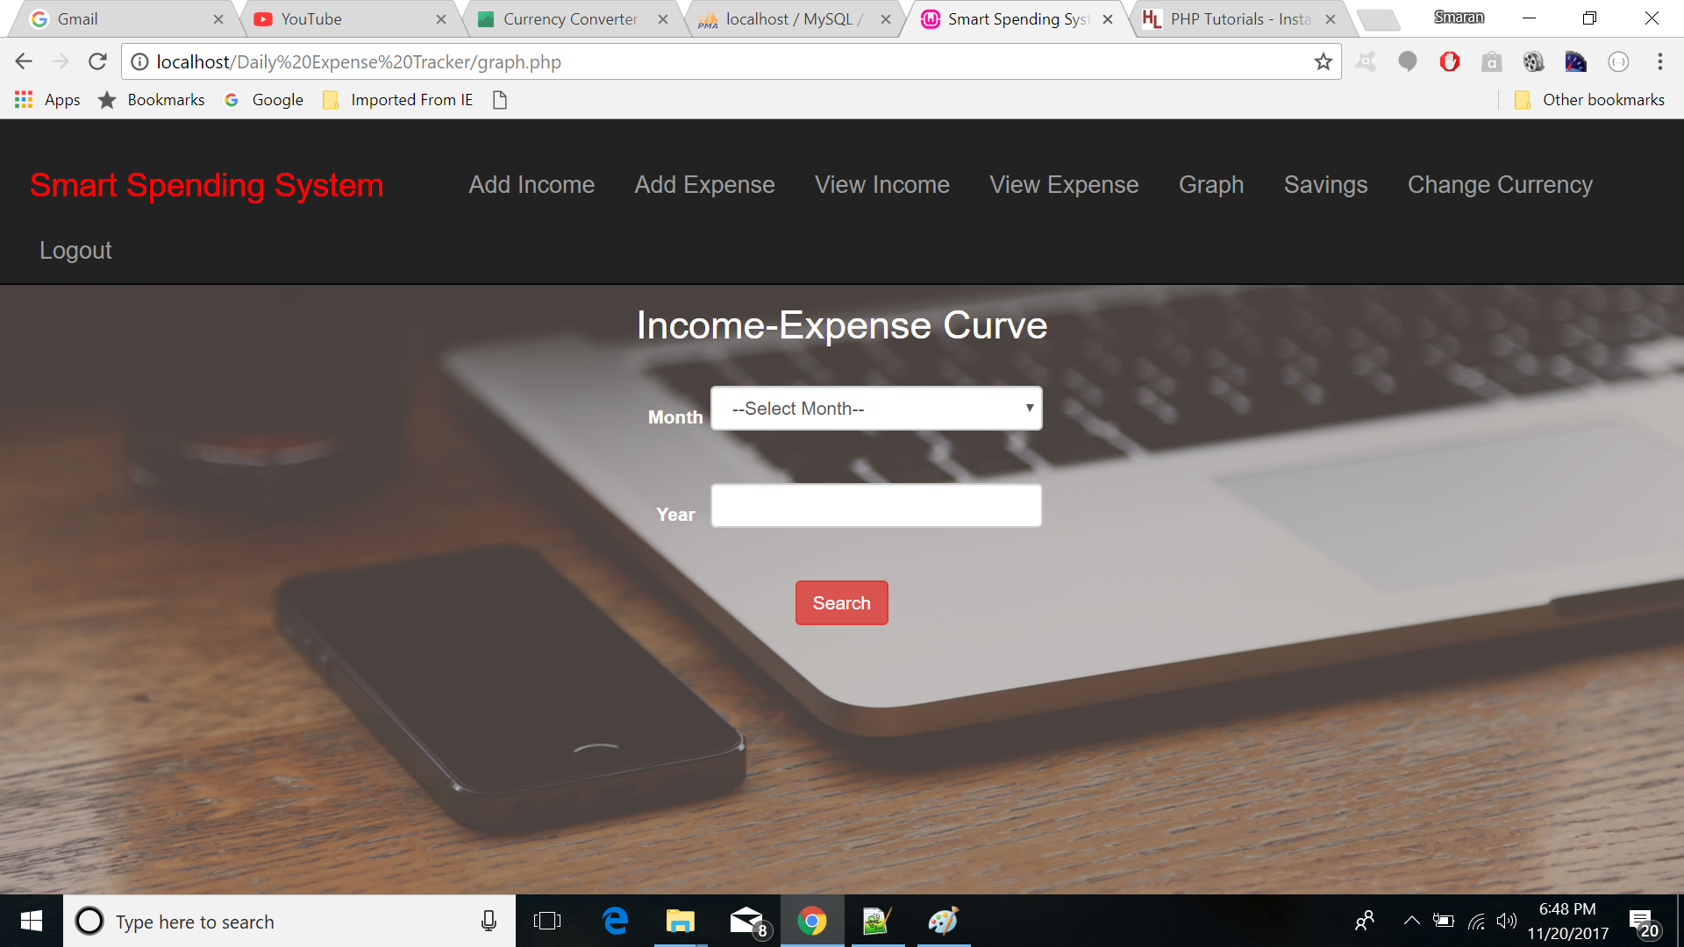

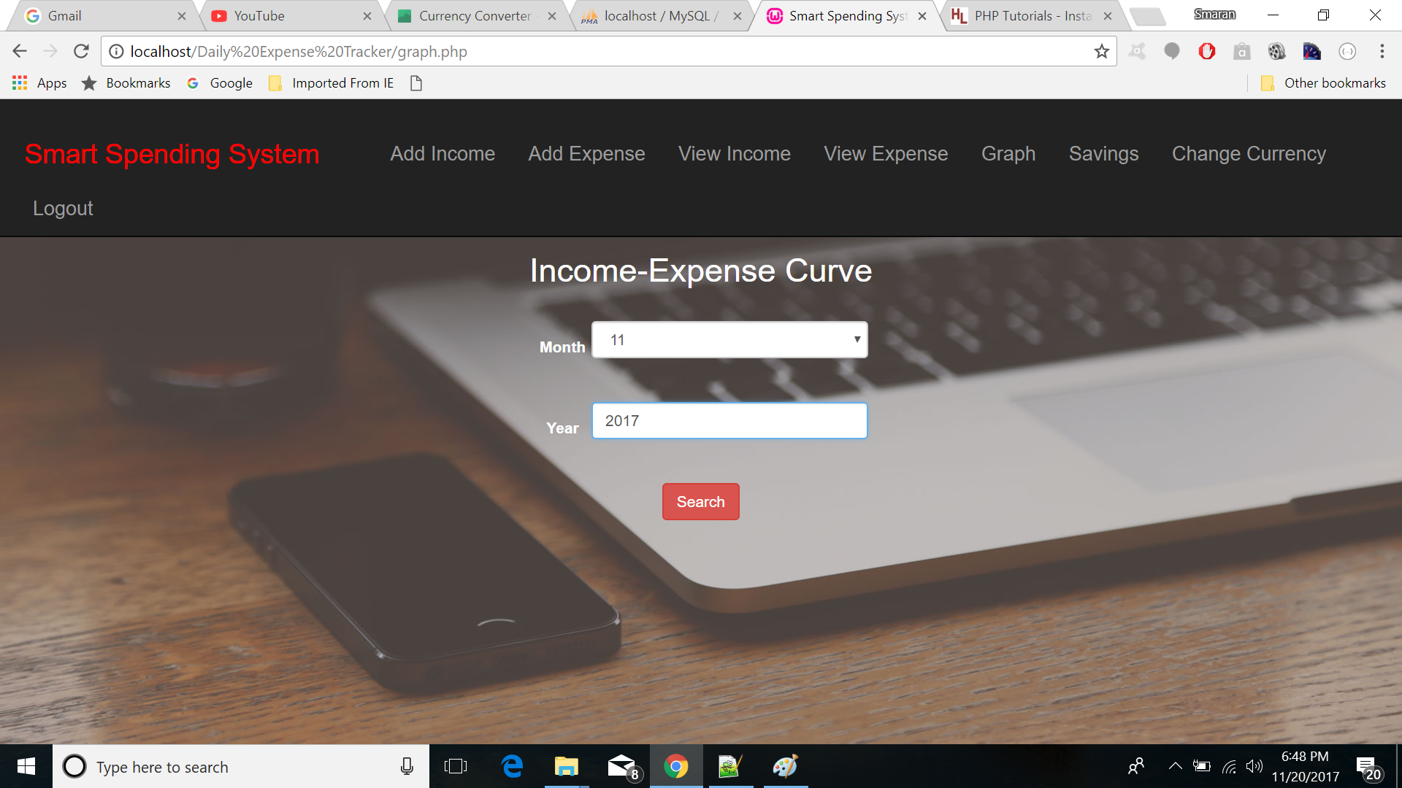

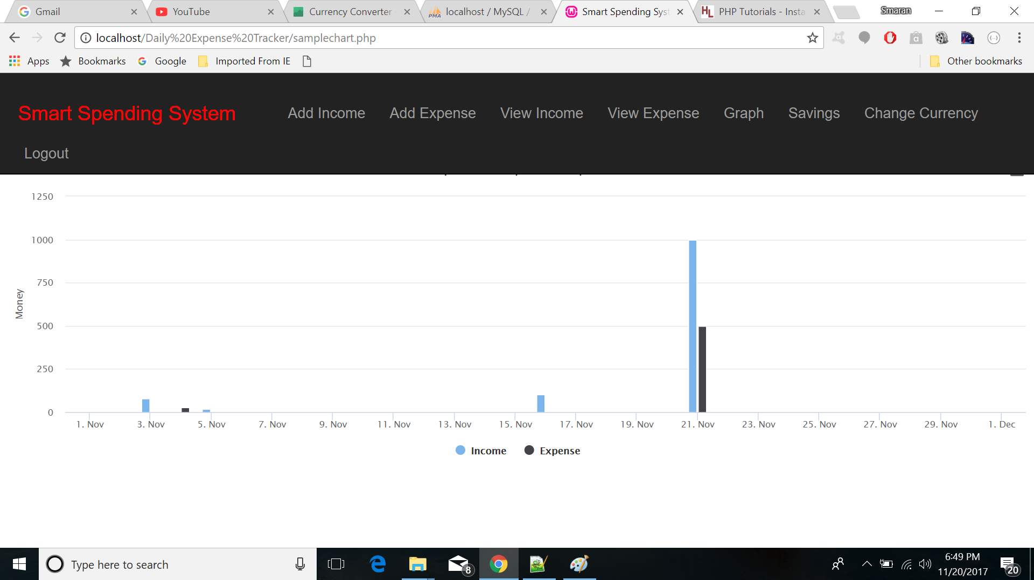

**CURRENCY SELECTION**

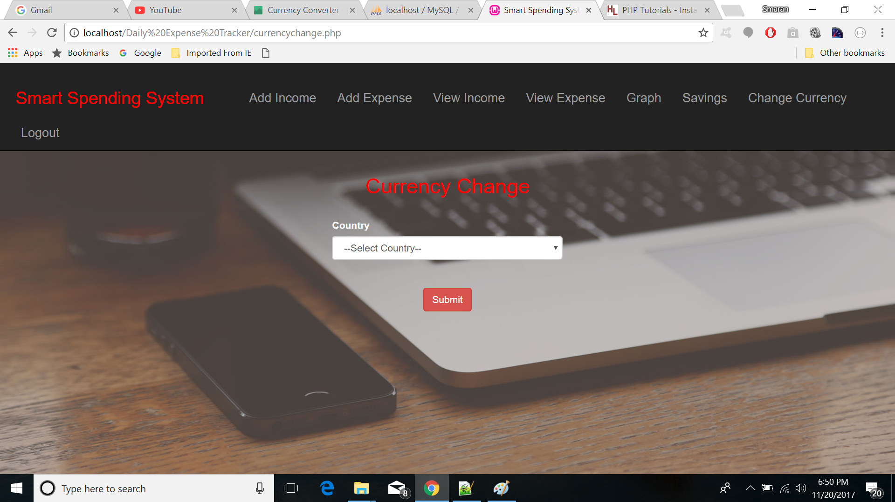

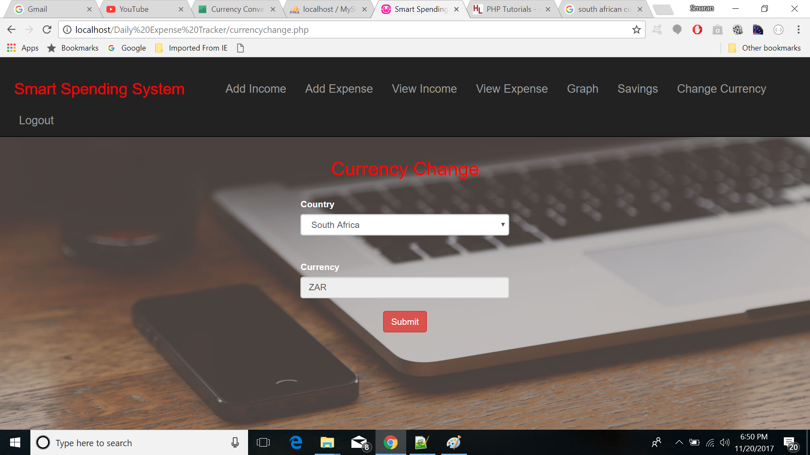

**PROJECT PRESENTATION SLIDES**











**PROJECT PROPOSAL**

***GOAL:***

To develop an application that helps people to keep a track on their income, expenditure and savings.

***OBJECTIVES:***

* The main aim of this project is to keep a virtual track on the money being spent by adding past, future or recurring transactions and categorizing them.
* It can be used to alert the user when he exceeds his pre-planned monthly limit or if his present month’s expenditure exceeds that of his previous month.

***SYSTEM FEATURES:***

* Detailed info graphics.
* Friendly email remainders to others.
* Easily accessible notifications.

***SIGNIFICANCE:***

Like Fitbit tracks your health, this application tracks your expenditure, helps you plan your budget. A country needs a budget plan, similarly even our income also can be used effectively if we have a budget plan. This application is an aid for our budget plan.

***PROJECT PLAN***

***DESIGN***

***WIREFRAMES***

**WELCOME PAGE**

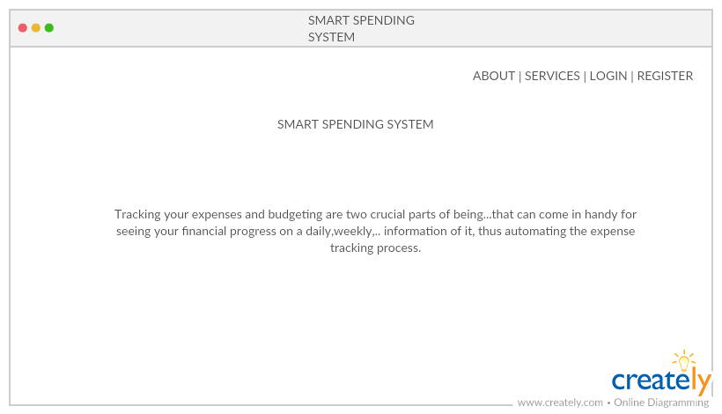

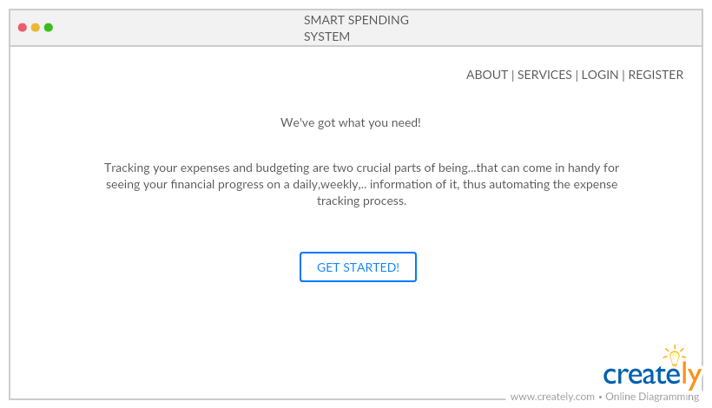

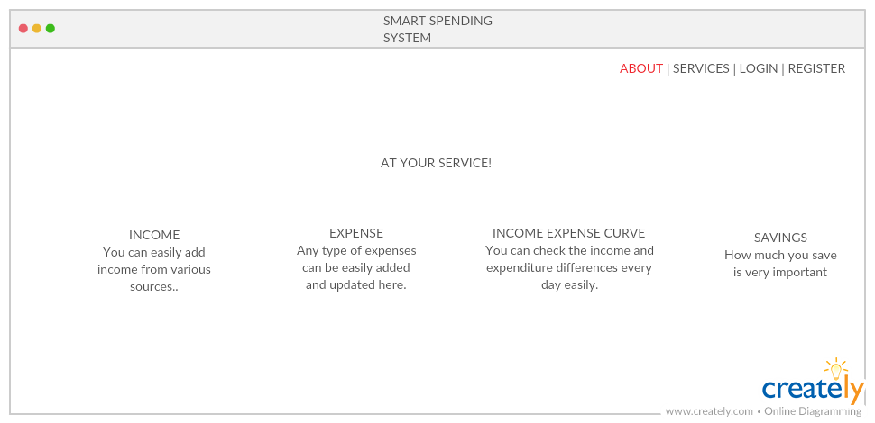

**LOGIN PAGE**

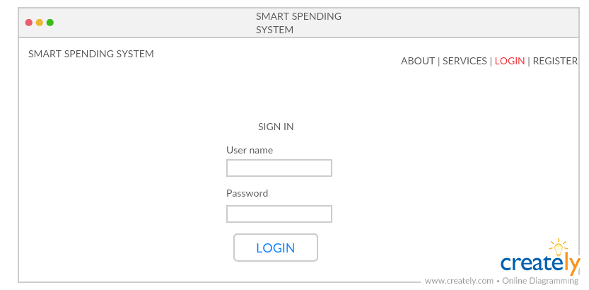

**ADD INCOME**

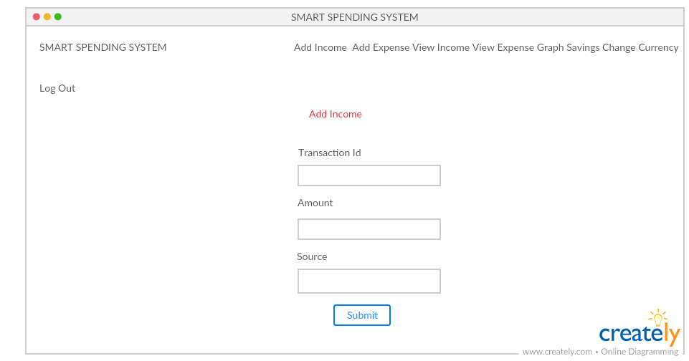

**ADD EXPENSE**

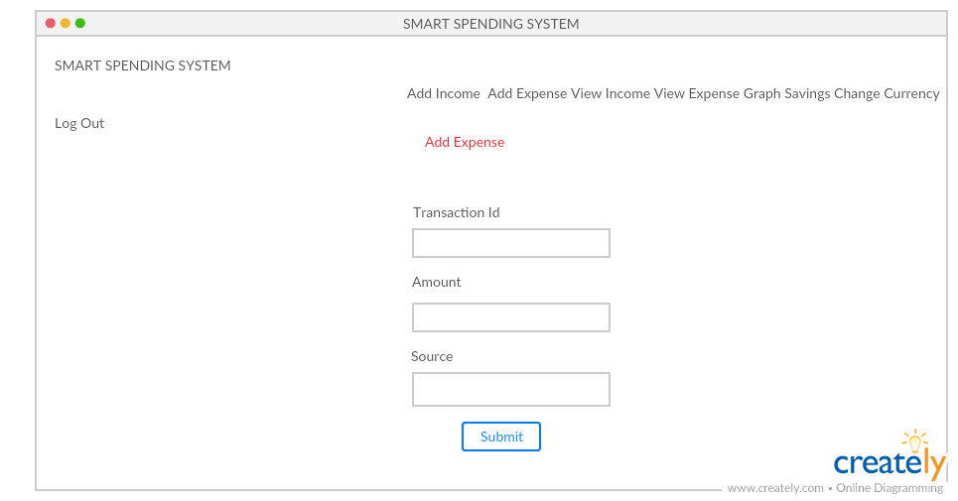

**VIEW INCOME**

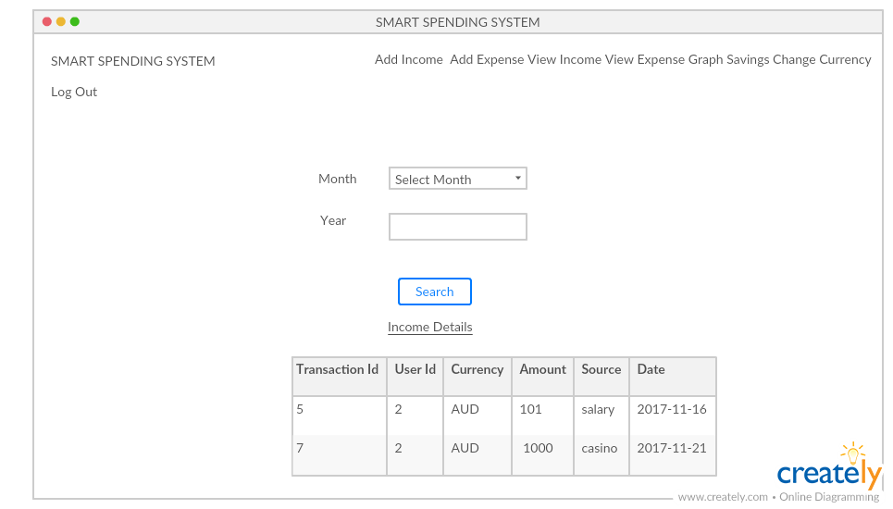

**VIEW EXPENSE**

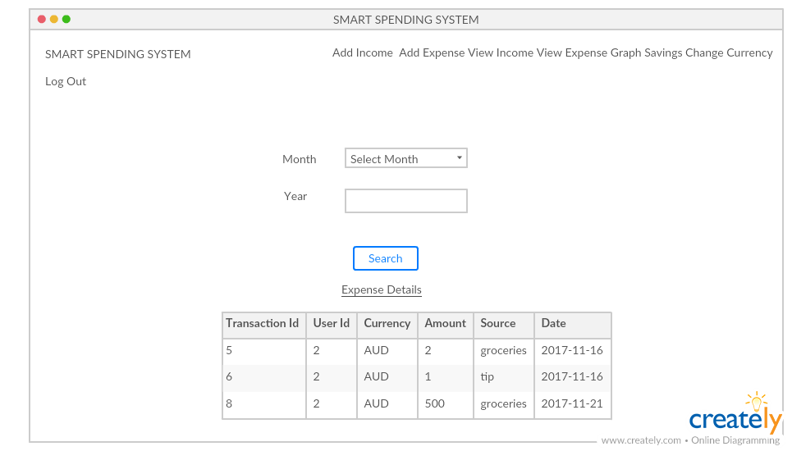

**INCOME EXPENSE CURVE**

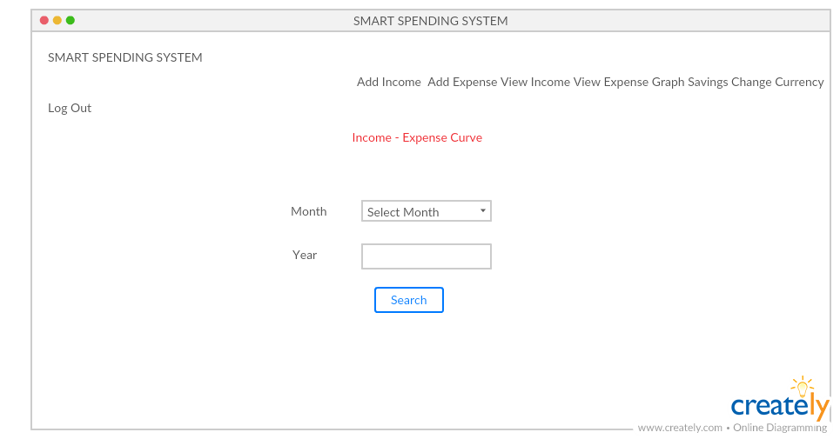

**SAVINGS**

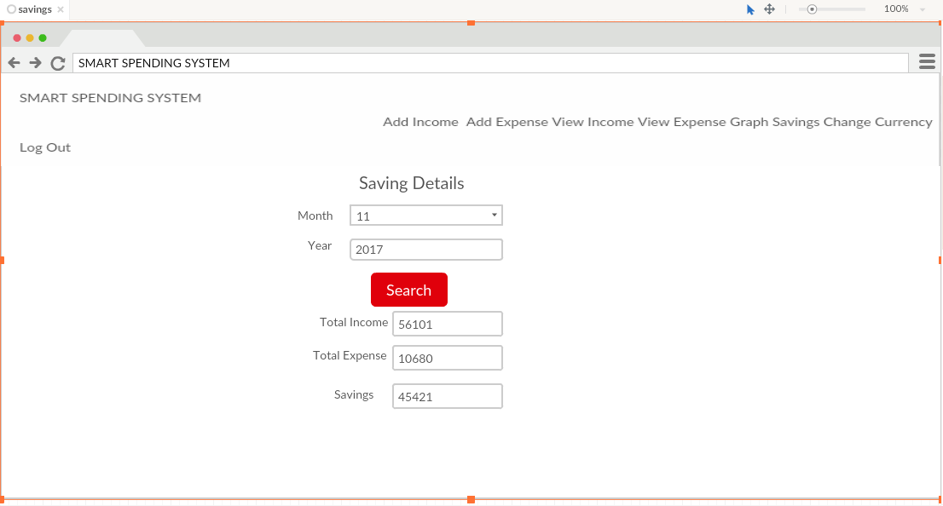

**CURRENCY SELECTION**

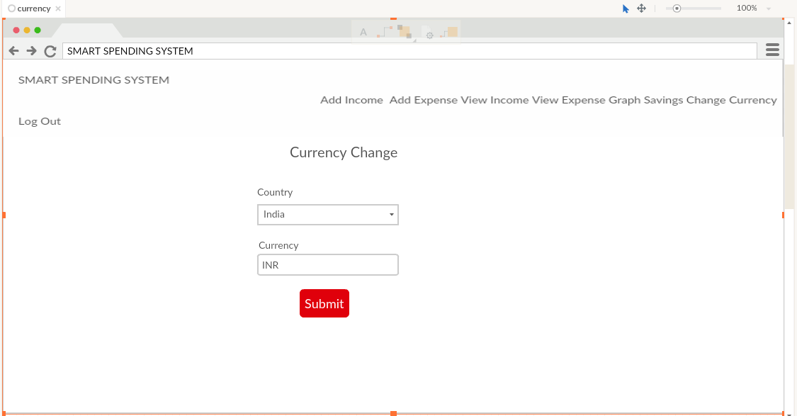

***ARCHITECTURE DIAGRAM***

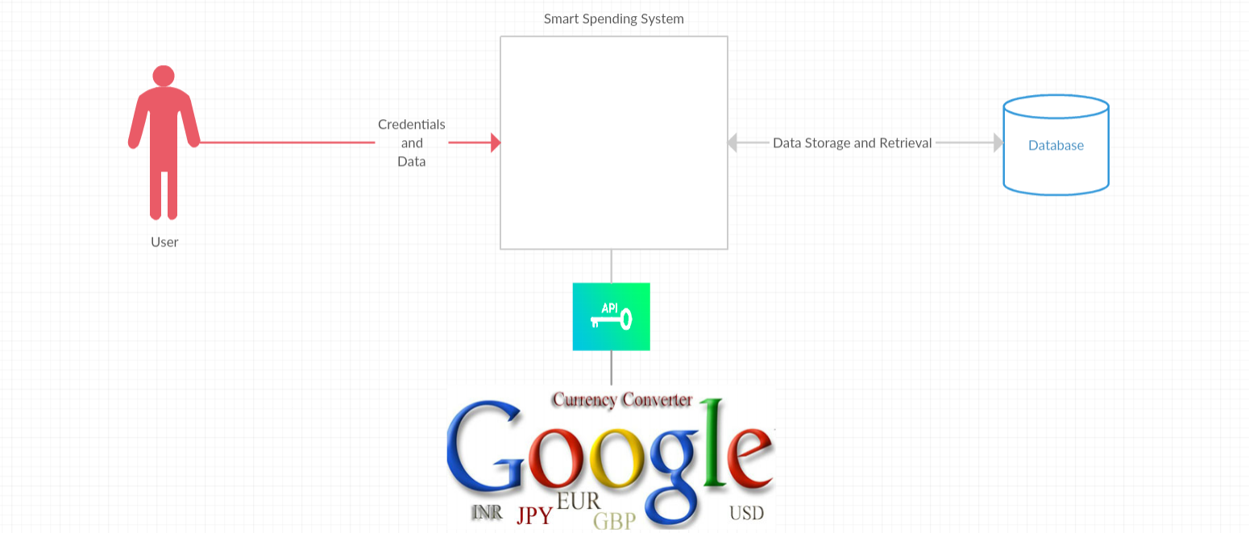

***CLASS DIAGRAM***

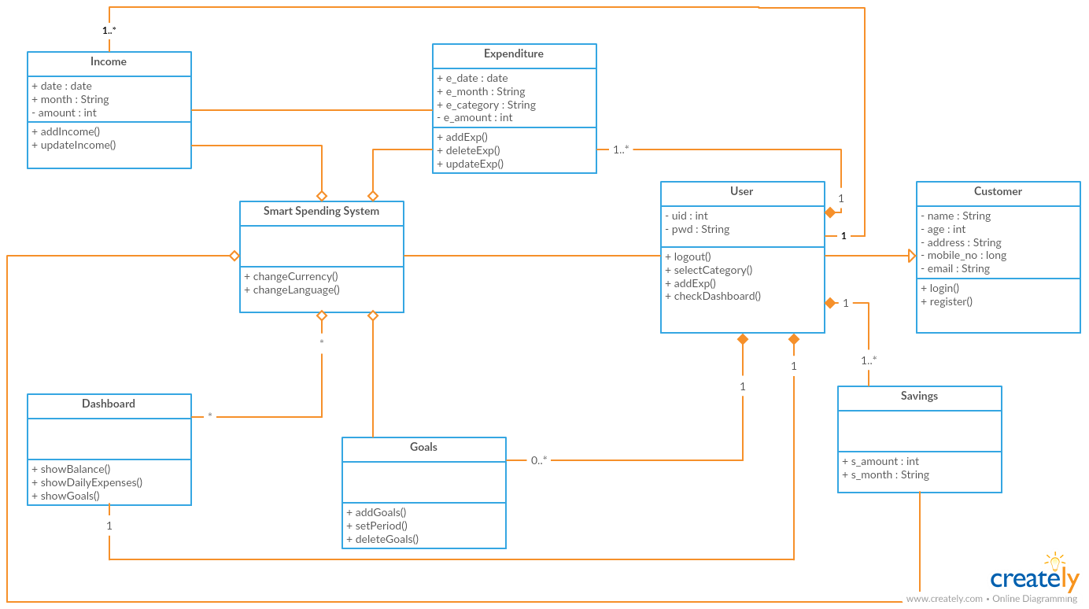

***SEQUENCE DIAGRAM***

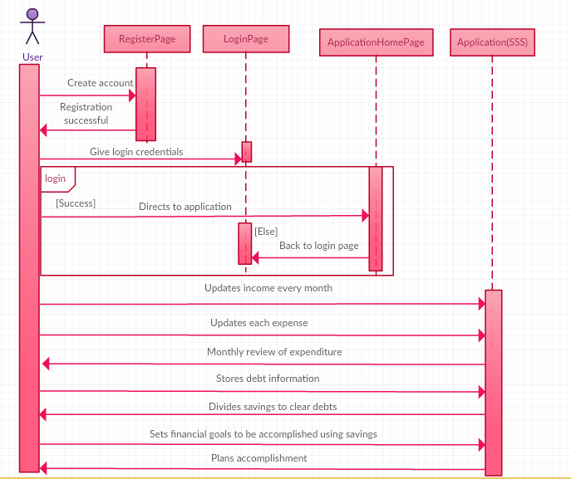

***USER STORIES***

* As a user, I want to register with the web application, so that I can start using the Smart Spending System.
* As a user, I want to login to the application, so that I can access my account.
* As a user, I want to keep a track on my savings, so that I can achieve my goals.
* As a user, I want to keep a track on my savings, so that I can clear my debt.
* As a user, I want to review my monthly expenditure, so that I can plan my budget better for the next month.
* As a user, I want to add the income for the current month, so that I can check my income for each and every month.
* As a user, I want to add the expense for the month in a particular year, so that I can keep my expense tracking.
* As a user, I want to view my income so that I can plan my budget.
* As a user, I want to view my expenses so that I can keep a track of on my expensed.
* As a user, I want to view my balance so that I can be able to know the amount left.
* As a user, I want to view my savings of the particular month and year.
* As a user, I want to view my income VS expense curve for the selected month and year.
* As a user, I want to change the currency of the country and display the selected country currency.

***USE CASE DIAGRAM***

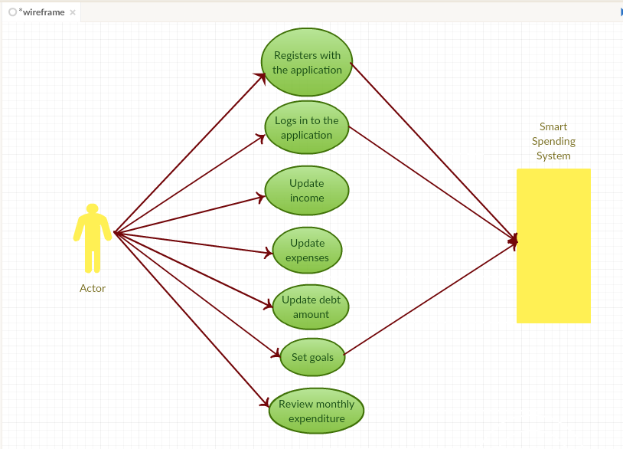

**FIRST INCREMENT**

**IMPLEMENTATION**

* Homepage
* Login
* Register

**REPORT**

[**https://github.com/SwetchaReddy/ASE-Project/blob/master/Documentation/ProjectIncrement1.docx**](https://github.com/SwetchaReddy/ASE-Project/blob/master/Documentation/ProjectIncrement1.docx)

**SECOND INCREMENT**

**IMPLEMENTATION**

* Add Income
* Add Expense
* View Income
* View Expense
* Local Storage

**REPORT**

[**https://github.com/SwetchaReddy/ASE-Project/blob/Avinash/Documentation/Increment2.docx**](https://github.com/SwetchaReddy/ASE-Project/blob/Avinash/Documentation/Increment2.docx)

**THIRD INCREMENT**

**IMPLEMENTATION**

* View Savings
* API Implementation
* Database

**REPORT**

[**https://github.com/SwetchaReddy/ASE-Project/blob/master/Documentation/Increment%203/Increment3.docx**](https://github.com/SwetchaReddy/ASE-Project/blob/master/Documentation/Increment%203/Increment3.docx)

**FOURTH INCREMENT**

**IMPLEMENTATION**

* Income-Expense Curve
* API Implementation

**REPORT**

[**https://github.com/SwetchaReddy/ASE-Project/tree/Avinash/Documentation/increment%204**](https://github.com/SwetchaReddy/ASE-Project/tree/Avinash/Documentation/increment%204)

**PROJECT MANAGEMENT**

**ZENHUB**

**ISSUES**

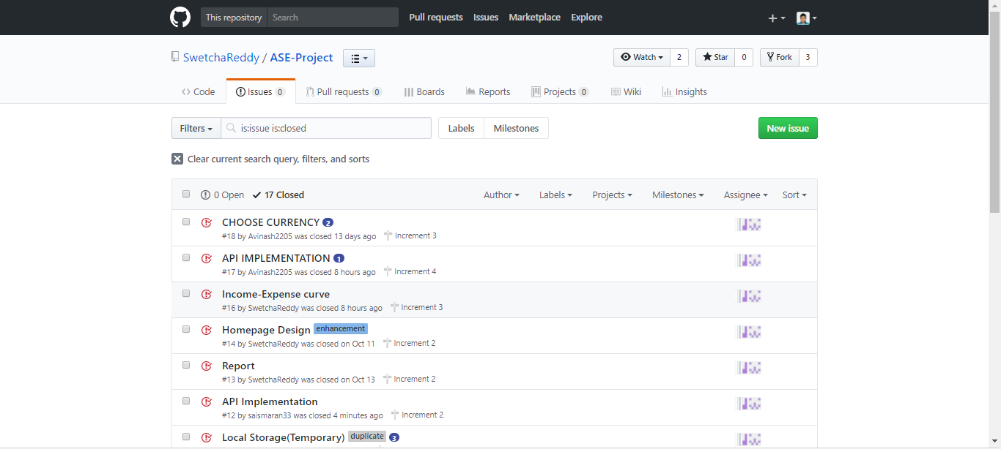

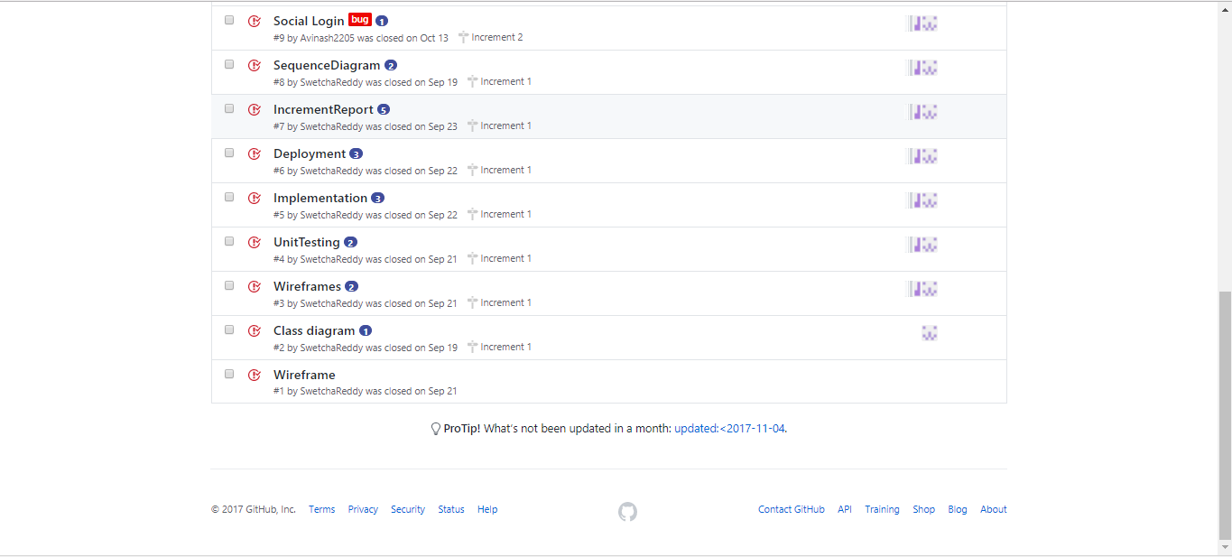

**BOARDS**

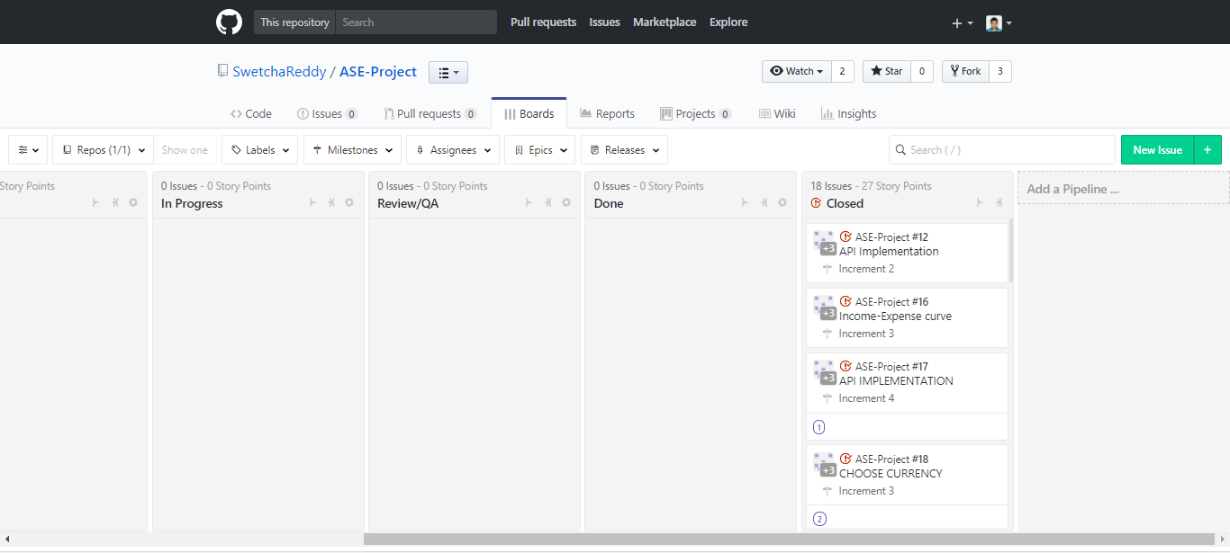

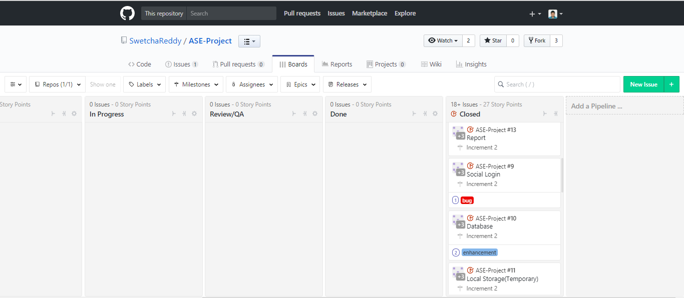

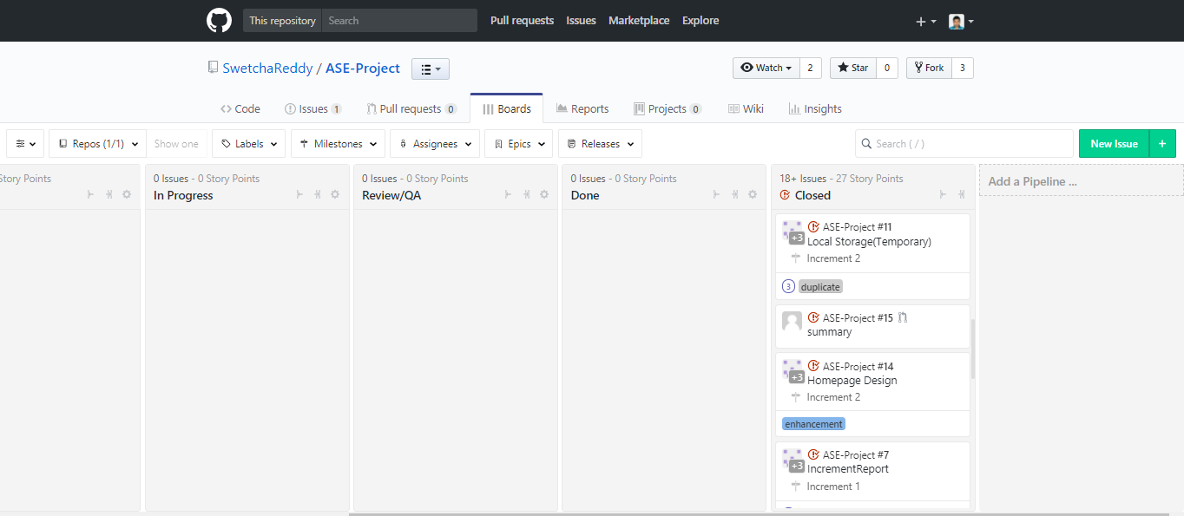

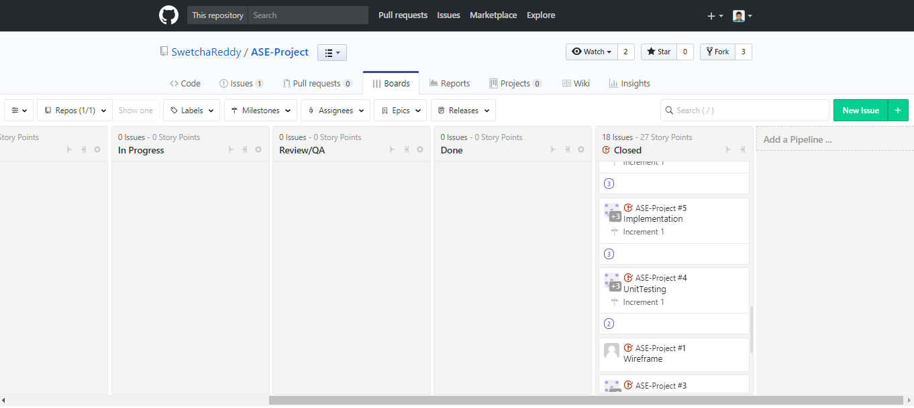

**BURNDOWN CHART**

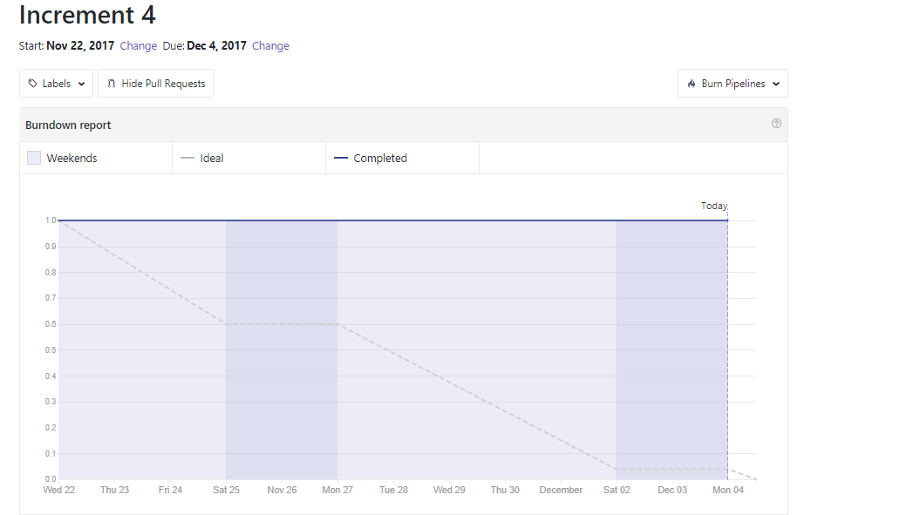

**TEAM MEMBERS**

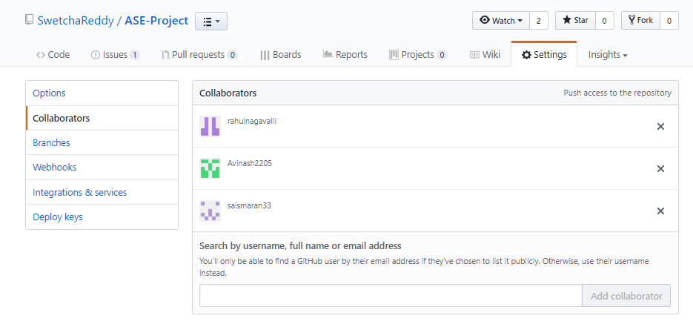

***REST APIs USED***

For this application to become a global application, for this to be accessible to people all over the world, a currency API is required. The API which we use for this application is **Google Currency Converter API.**

Google provides Currency Converter API for converting currency to our desired currency. We can see the current status of our currency into other currency by going through [**Google’s currency converter**](http://www.google.com/finance/converter) page. However, sometimes we need to implement Google currency converter functionality on our application.

There are basically 3 parameter required: From Currency, To Currency and Amount.

***TESTING***

***UNIT TESTING:***

|  |  |  |  |  |
| --- | --- | --- | --- | --- |
| **Test Case no.** | **Test Case** | **Description** | **Expected**  **Output** | **Result** |
| 1. | Successful  User Authentication | The user should login with username and password. | Successful Login | Pass |
| 2. | Unsuccessful  User  Authentication | The user logs in with wrong username or password | Login unsuccessful with error-Invalid username or password | Pass |
| 3. | Registration by new user | Admin accepts registration details from the user | Successful registration and transition to Login page | Pass |
| 4. | Add Income | User can add his income for the month | Successful authentication of income is added | Pass |
| 5. | Add Expense | User can add his expense for the month | Successful type of expense is added | Pass |
| 6. | View Income | User can view his income. | Income is viewed for the month | Pass |
| 7. | View Expense | User can view his expense. | Expense is viewed for the month | Pass |
| 8. | Savings | User can view his savings based upon his income and expenses | Savings is viewed for the particular month | Pass |
| 9.` | Graph | User can view the income VS expense curve for the selected month and year. | Curve is displayed for the selected month | Pass |

**PERFORMANCE TESTING:**

The performance test has been implemented using Yslow Analyser, it will issue the grades according to the code Quality. These has been tested for all HTML files:

**HOME PAGE:**

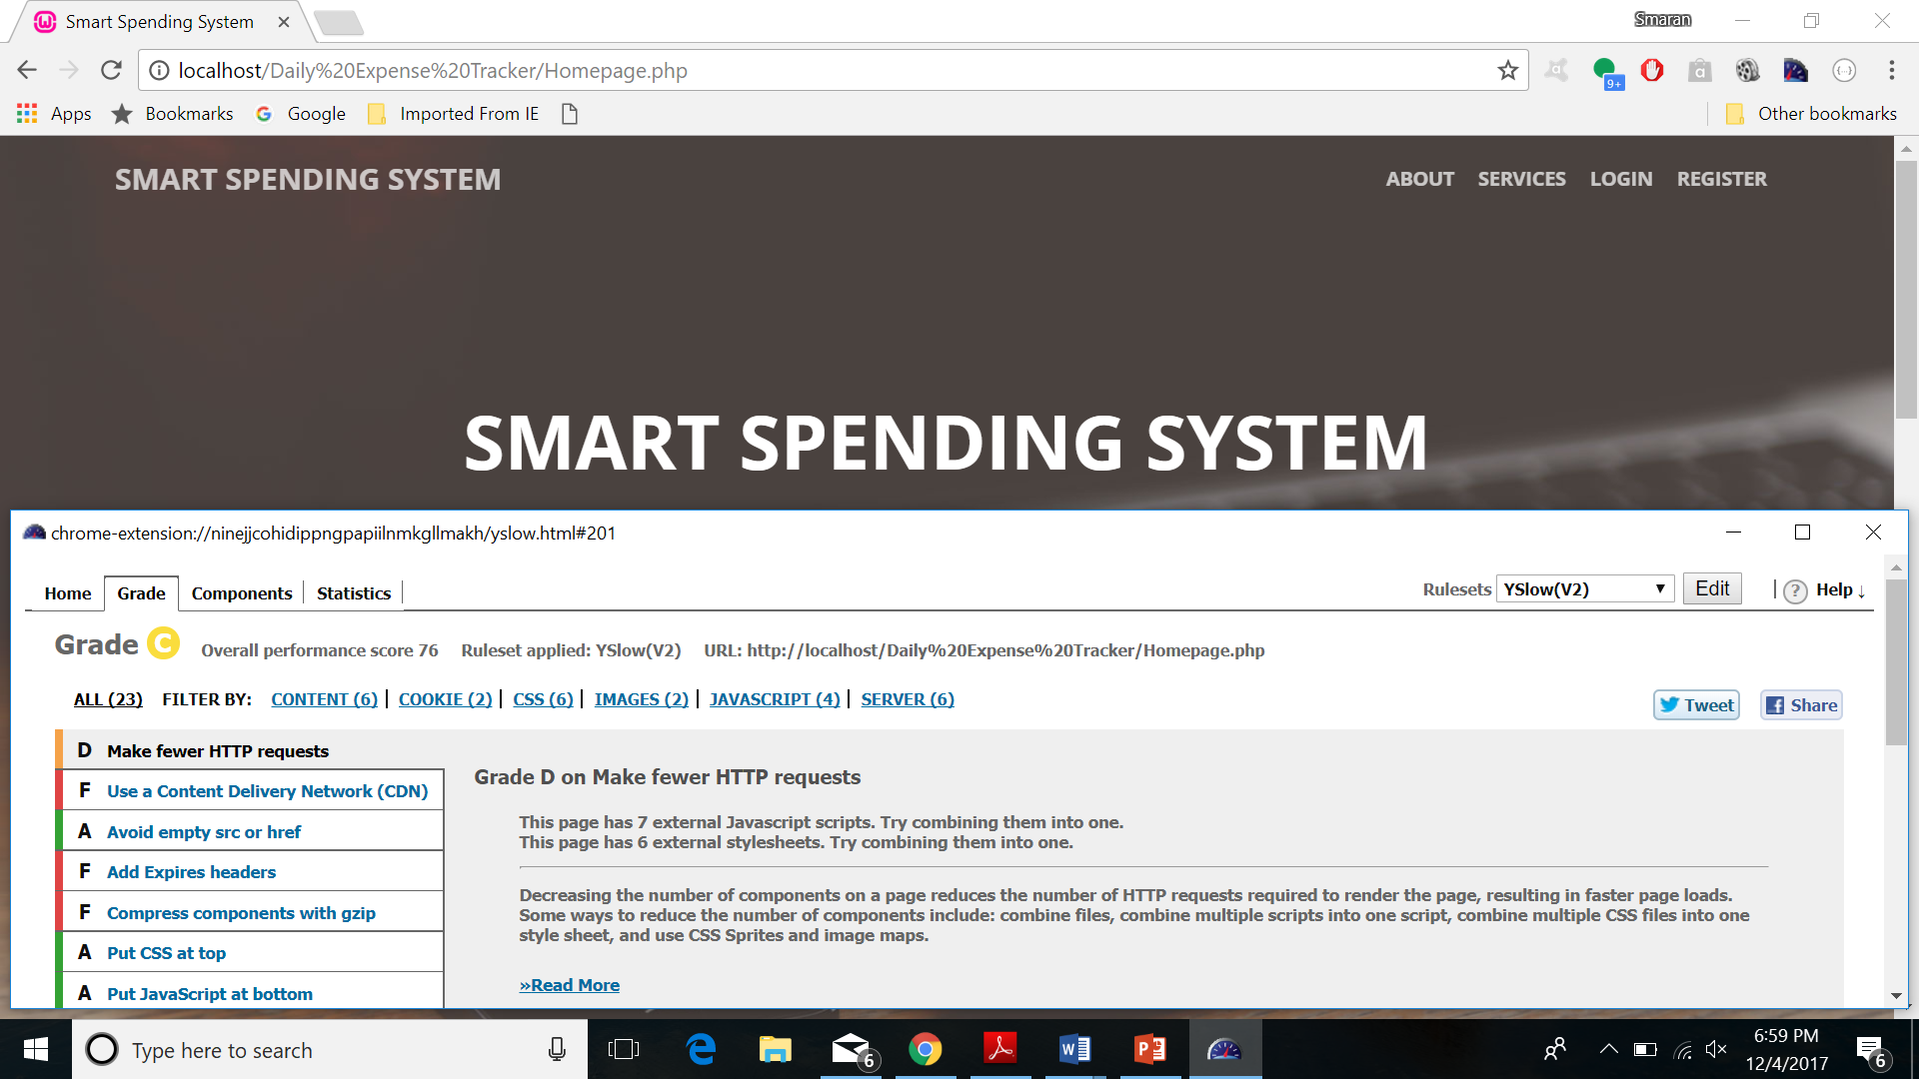

**REGISTRATION**:

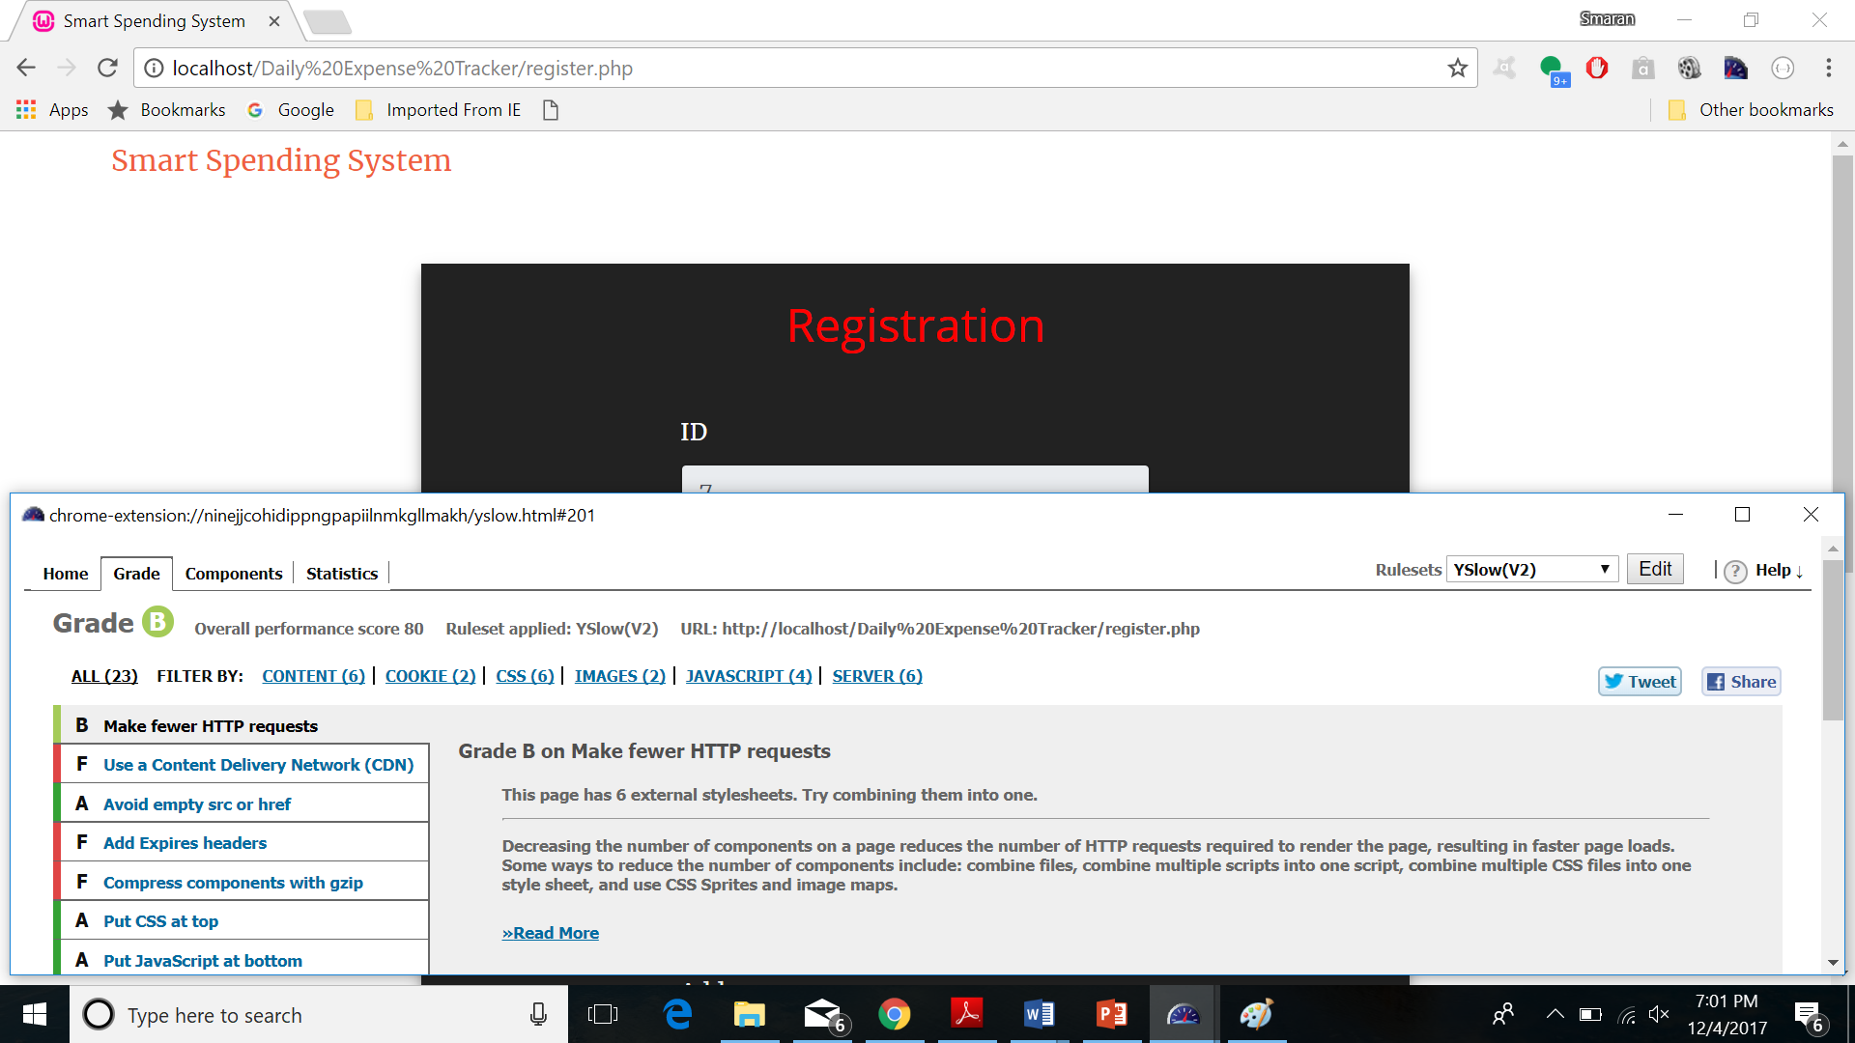

**ADD INCOME**

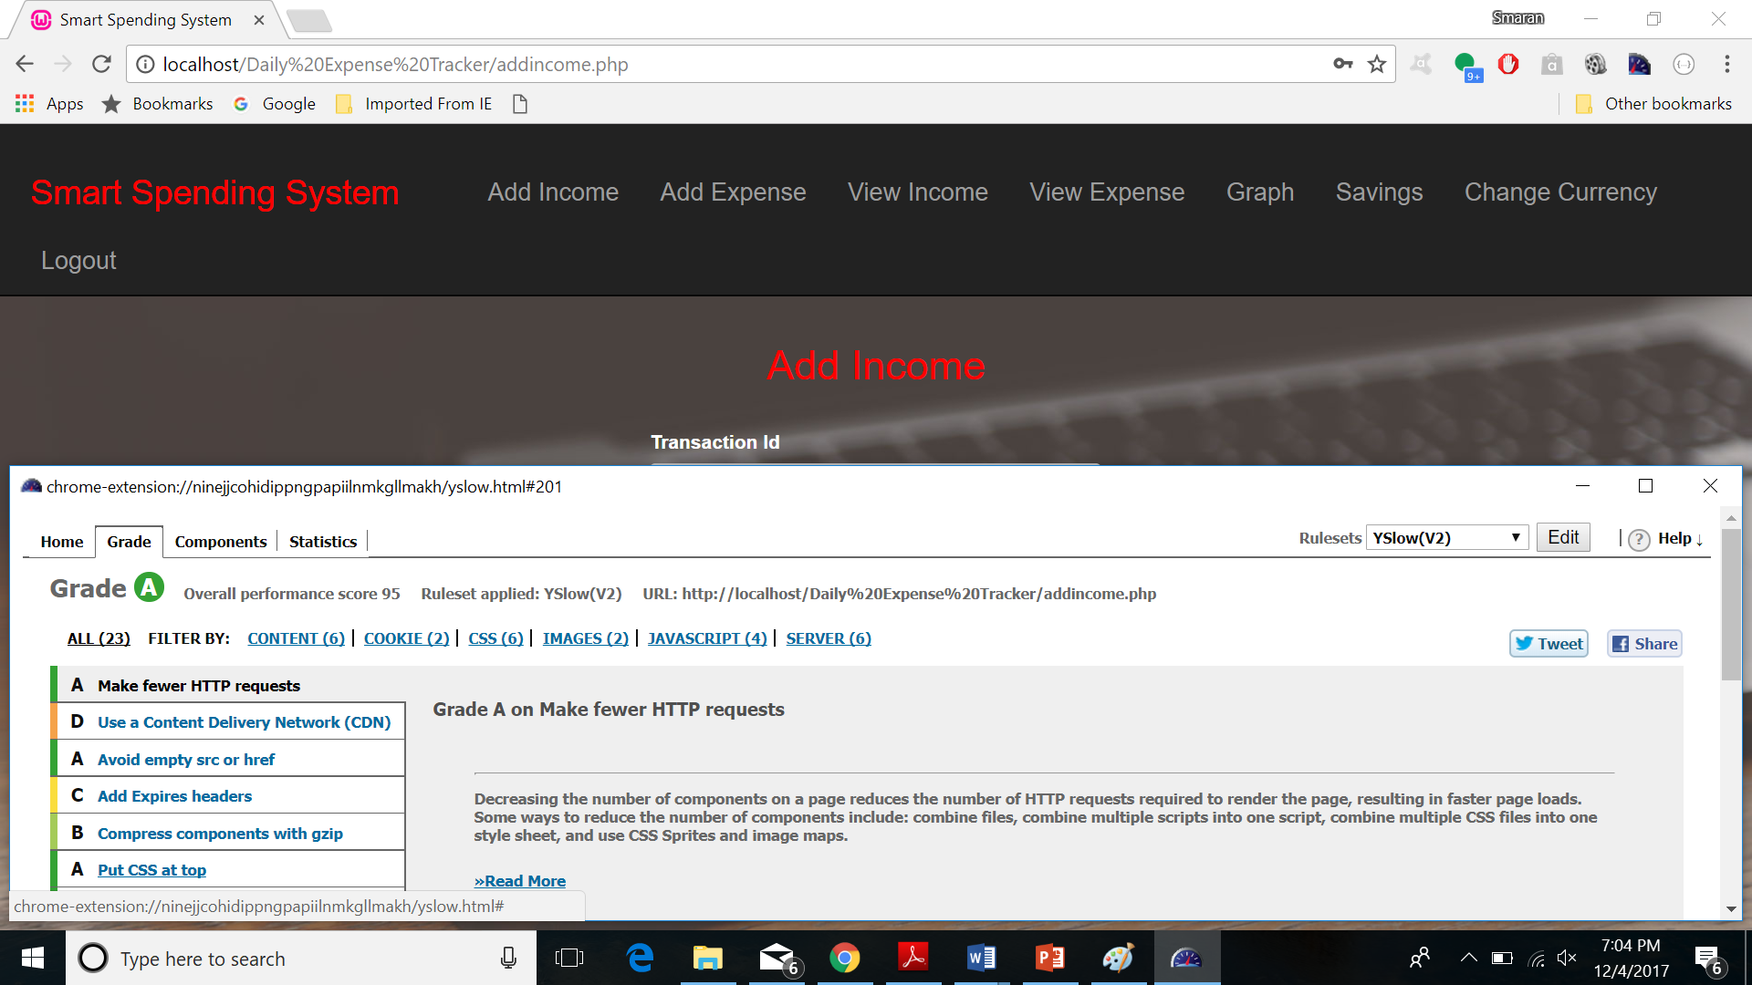

**ADD EXPENSE**

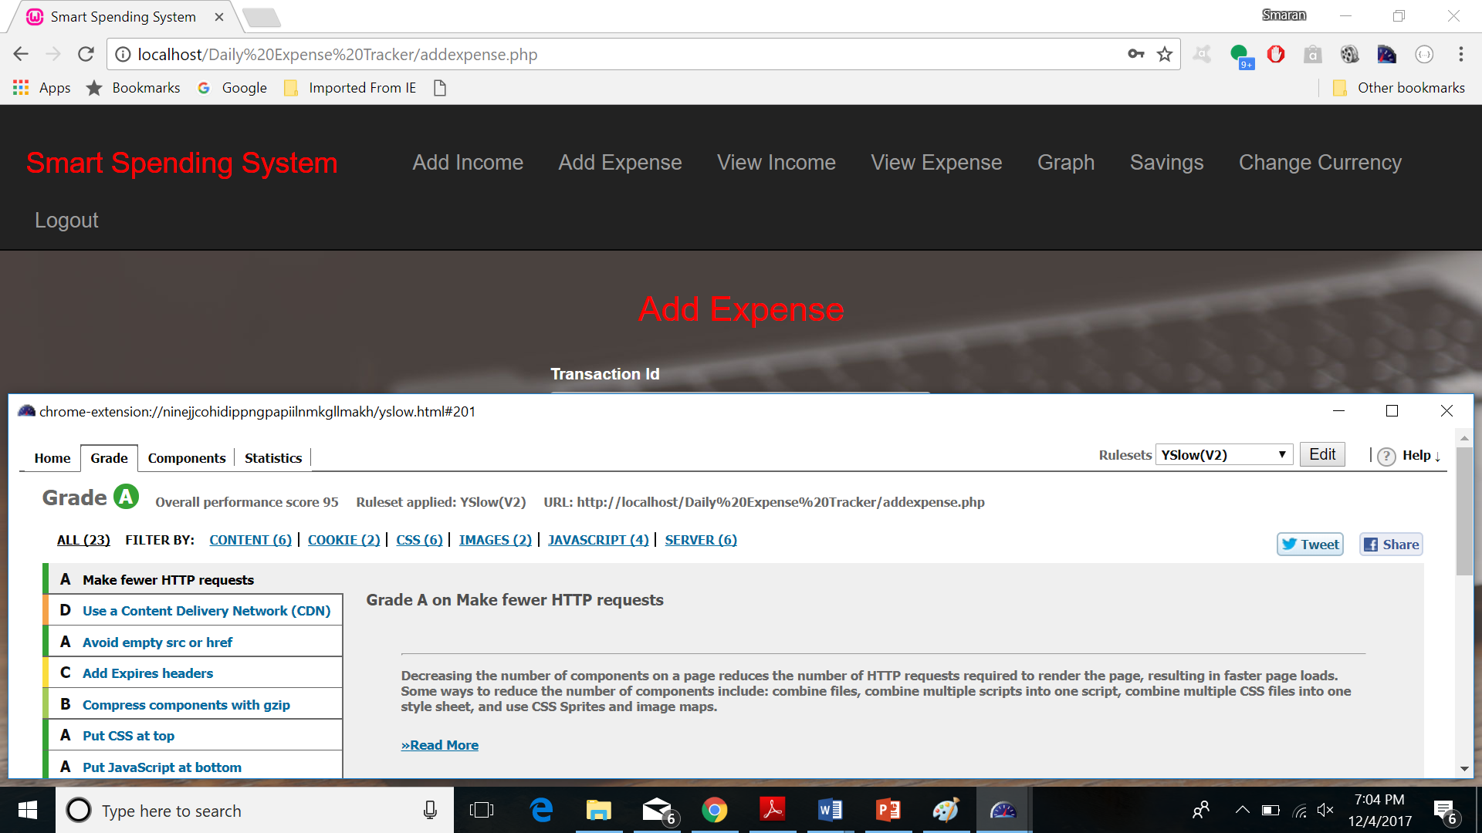

**VIEW INCOME**

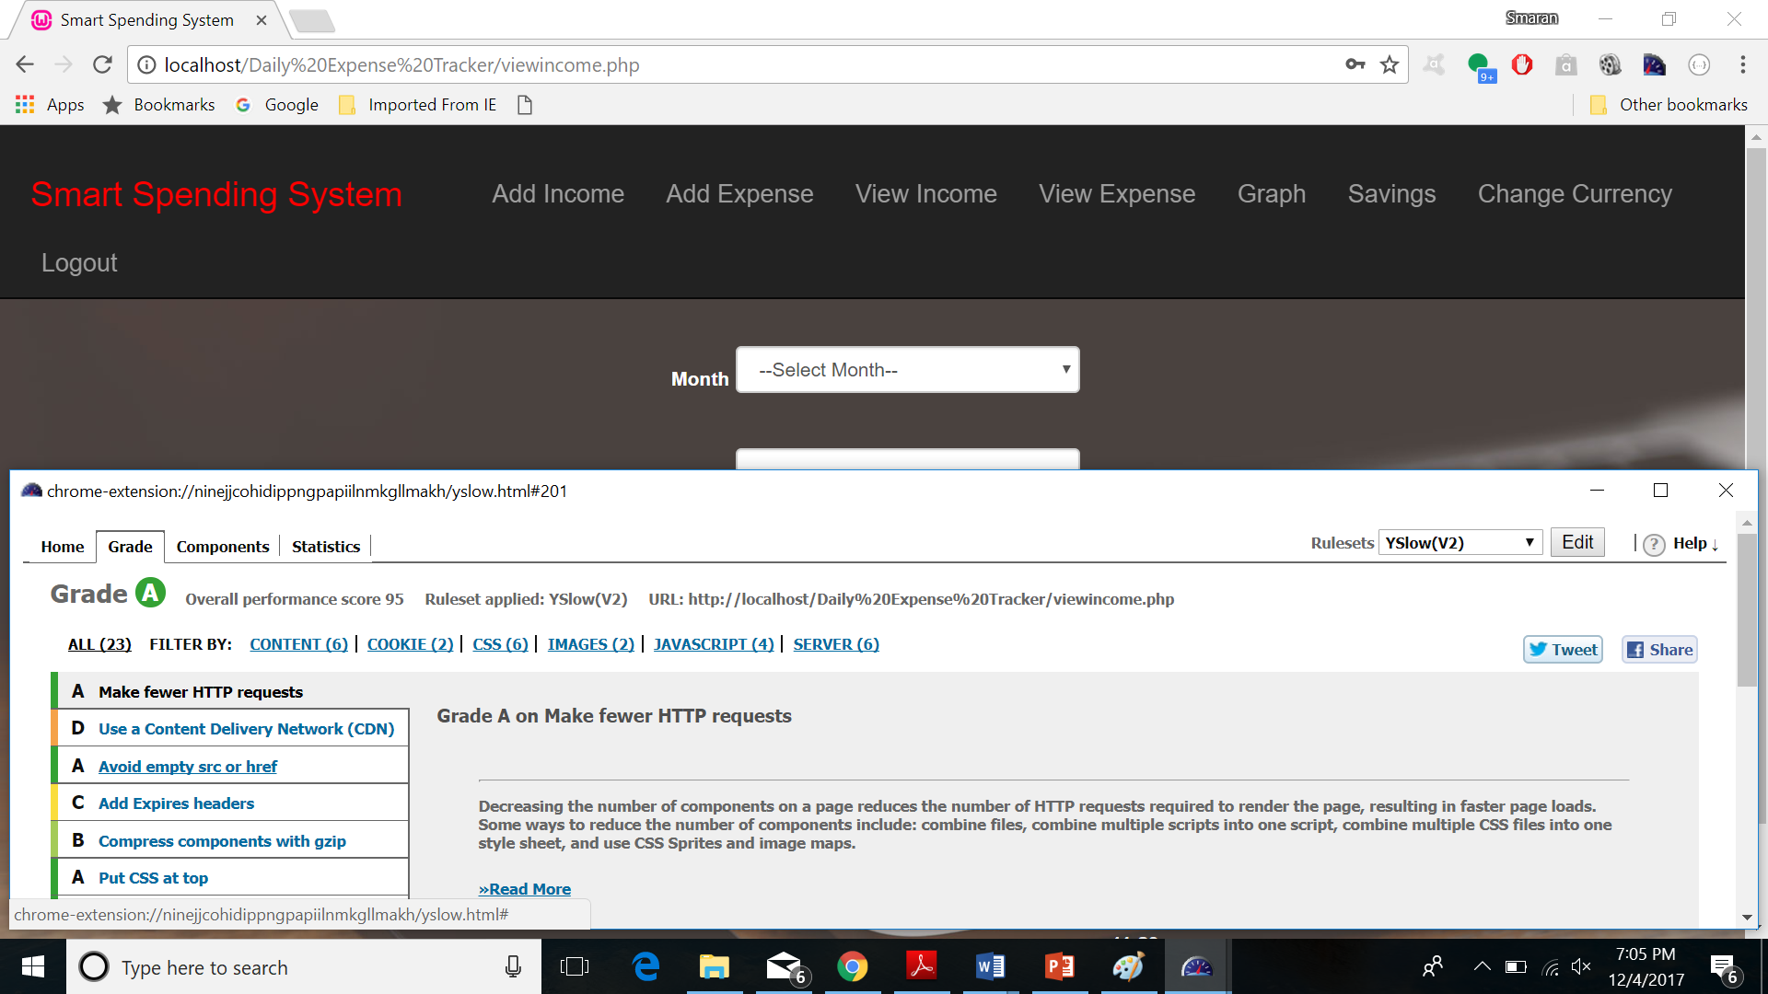

**VIEW EXPENSE**

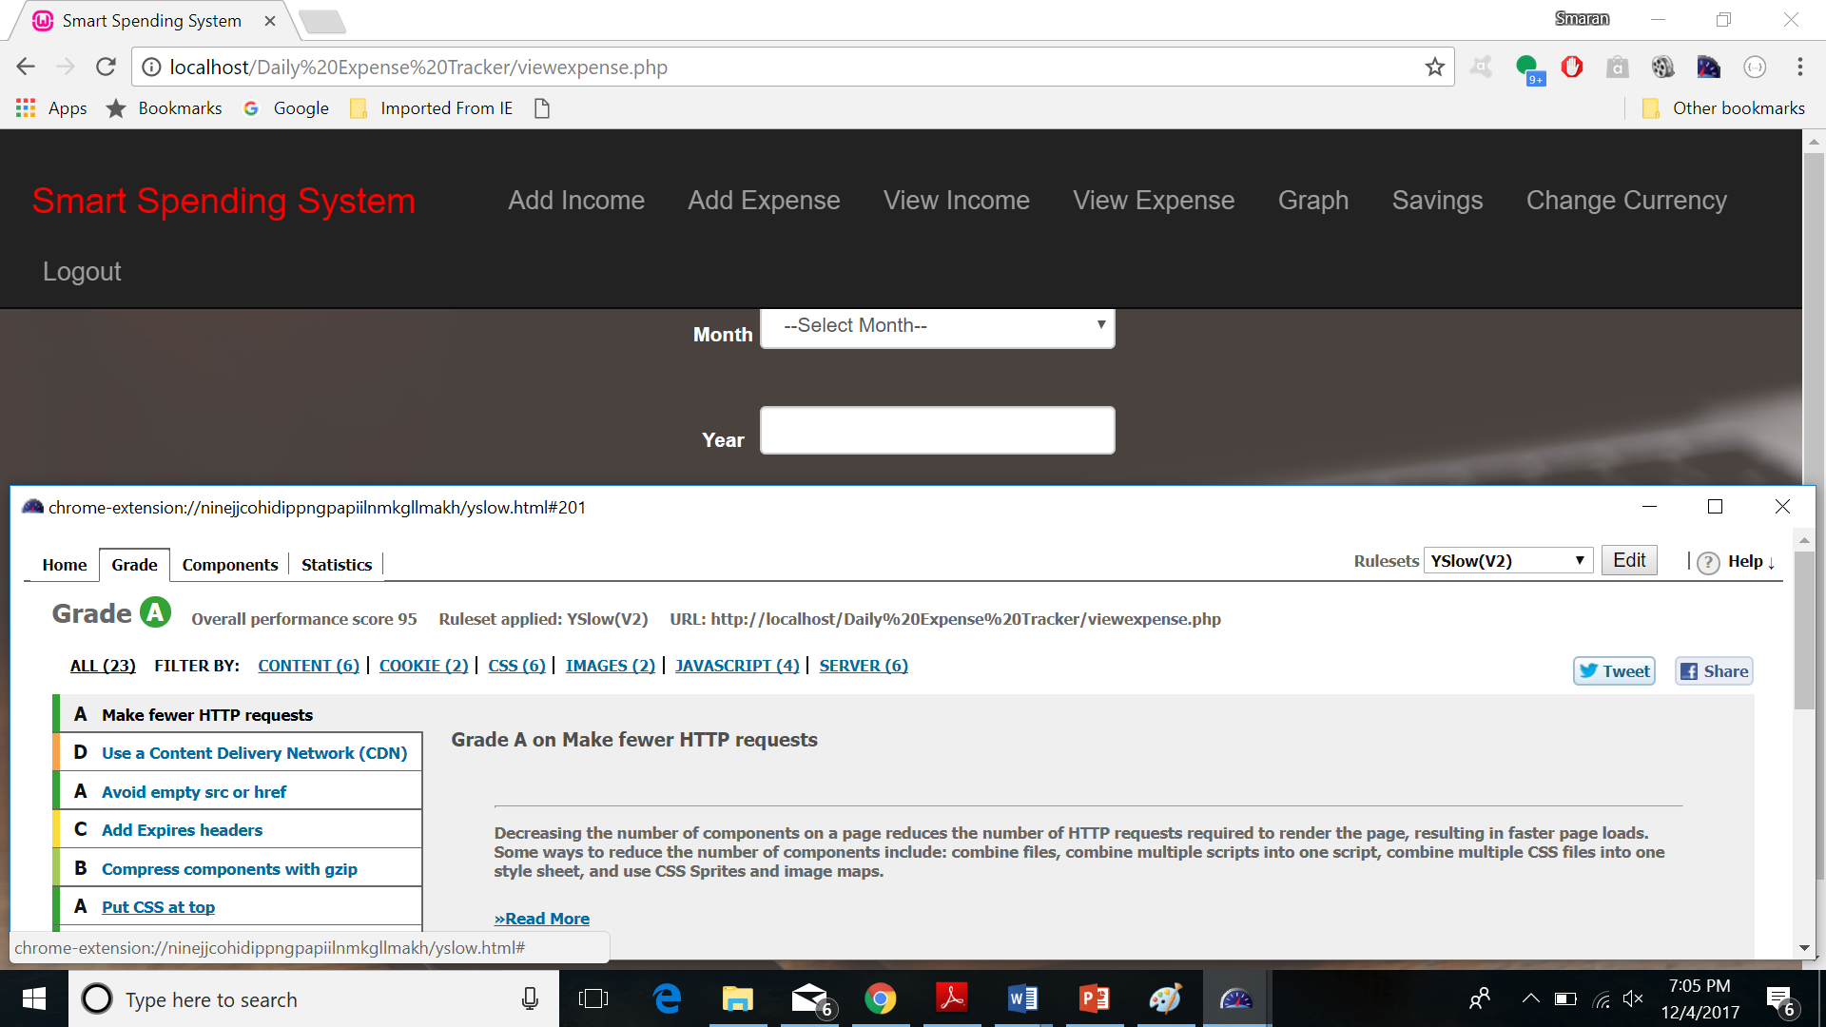

**GRAPH (INCOME EXPENSE CURVE)**

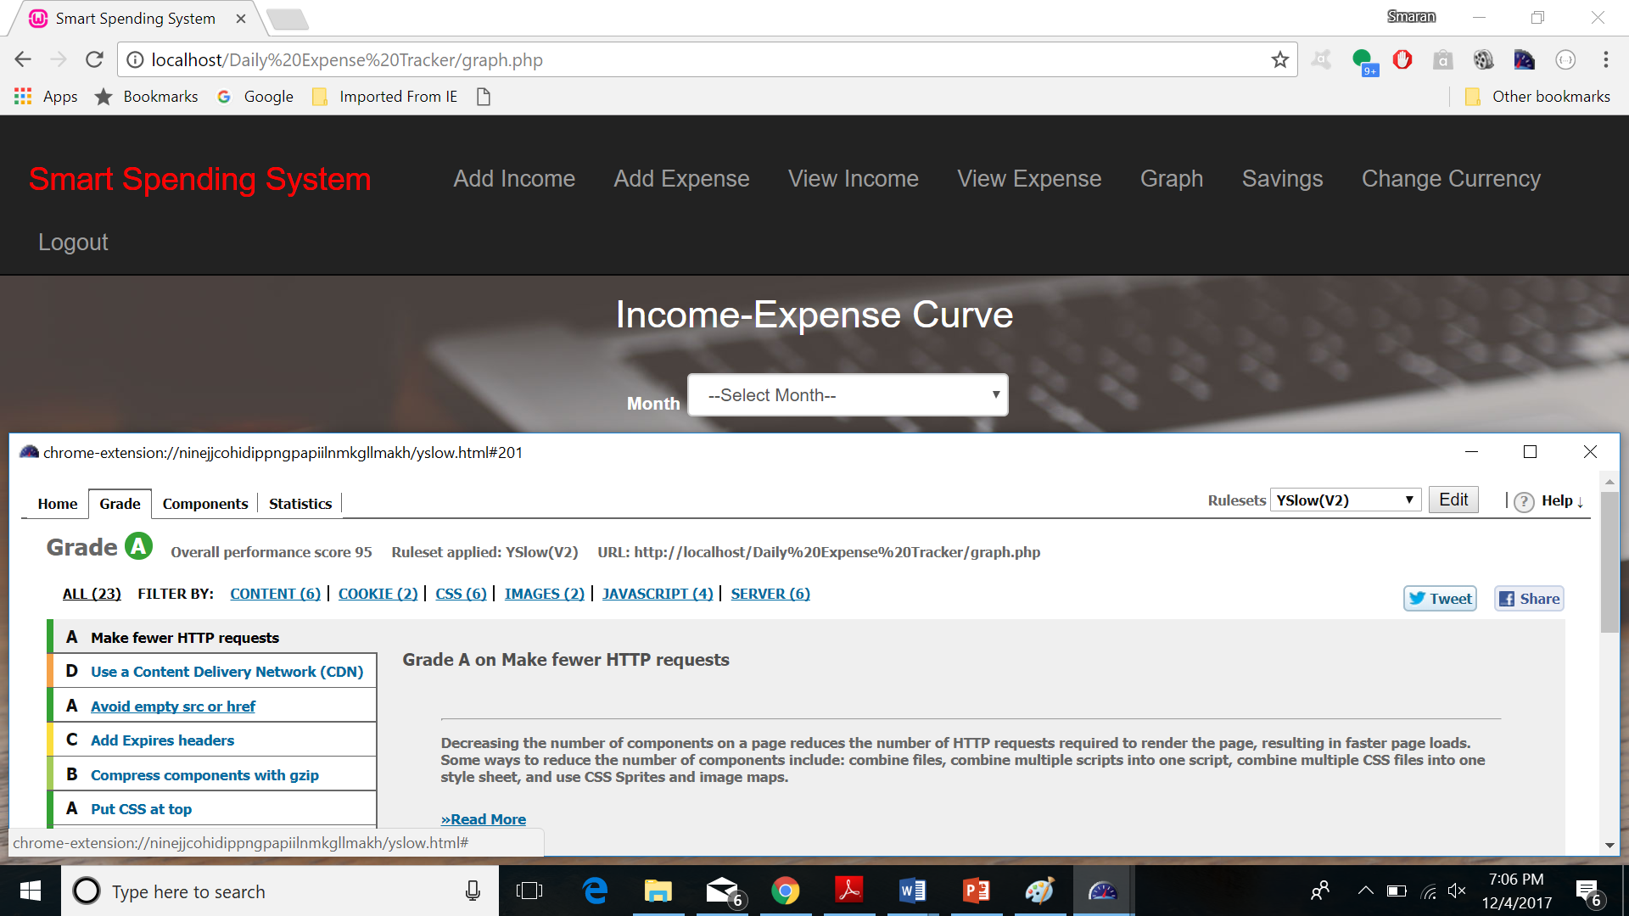

**SAVINGS**

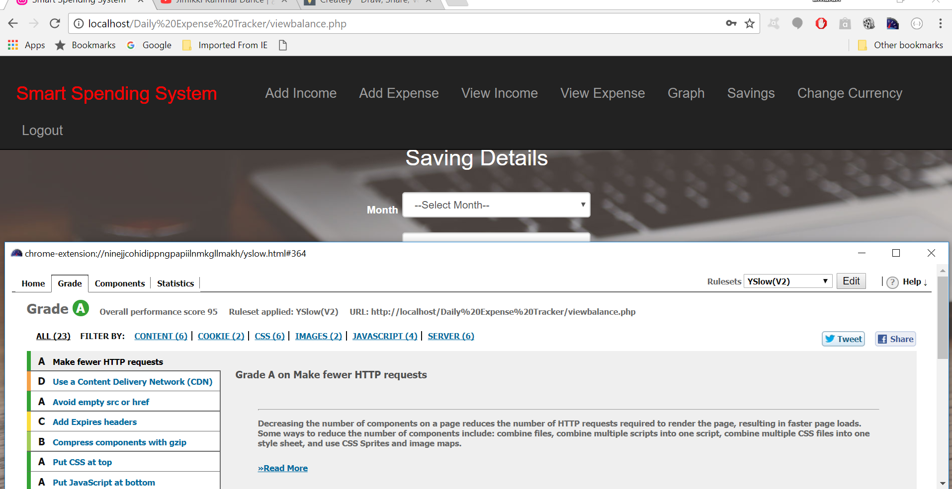

**CURRENCY CHANGE**

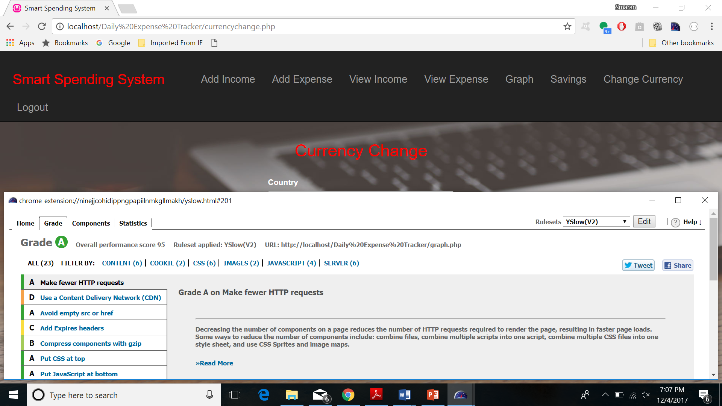

**STATUS REPORT**

***Work completed***

**Description**

* Created issues for each increment in GitHub.
* Created wireframes.
* Designed pages of Application
* Login
* Register
* Application page
* Add Income
* Add Expense
* View Income
* View Expense
* Savings
* View Income-Expense Curve
* Currency Change
* Implementation of the pages of the application.

**Responsibility**

**Task Person**

* Ground work for project All four in the team
* Issues Swetcha, Avinash
* Wireframes and Pages Design
* Home, Add Expense and View Income Swetcha Reddy Vangala
* Income-Expense Curve, View Expense Avinash Banala
* Register, Currency Selection Sai Smaran Chinthala
* Login, Add Income, Savings Rahul Nagavalli
* Documentation Avinash, Swetcha
* Local Storage Swetcha

**Time taken =** 90 days

**Contribution**

Swetcha Reddy Vangala – 25%

Avinash Banala – 25%

Sai Smaran Chinthala – 25%

Rahul Nagavalli – 25%

**Responsibility**

We developed the application together.

**Issues/Concerns** – No issues.

**Bibliography**

* + [**http://ieeexplore.ieee.org/document/7514640/**](http://ieeexplore.ieee.org/document/7514640/)
  + [**http://en.wikipedia.org/wiki/Model%E2%80%93view%E2%80%93controller**](http://en.wikipedia.org/wiki/Model%E2%80%93view%E2%80%93controller)
  + [**http://www.sparxsystems.com/platforms/software_development.html**](http://www.sparxsystems.com/platforms/software_development.html)
  + [**https://www.tutorialspoint.com/html/**](https://www.tutorialspoint.com/html/)
  + [**https://www.w3schools.com/css/**](https://www.w3schools.com/css/)